Eric James Gordon
January 6, 1948 – November 6, 2014

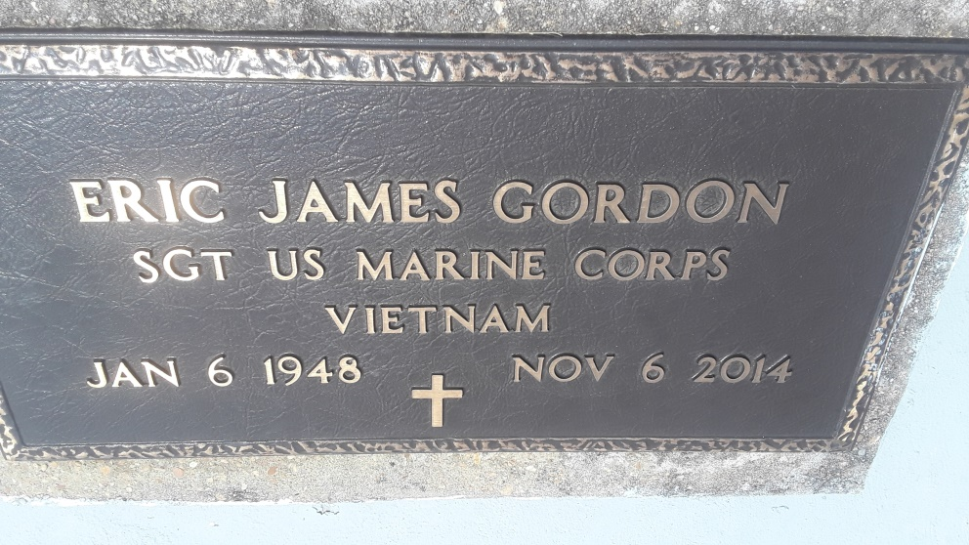
Survived by a daughter, Jessica Gordon. Four sons: Eric Taylor and wife, Anita, Marcus, Jonathon, and Ahmad Johnson. His father, Willie Gordon. A brother, Aaron Gordon, and wife, Laverne and Kevin White and wife, Ilana, 9 grandchildren, 2 great-grandchildren, mother in law, Senora Matthews, aunts, uncles, nieces, nephews, cousins, other relatives, and friends. Preceded in death by his mother, Doroline Clark Gordon. His wife, Irma Jean Gaines Gordon, and his sister, Wanda Gordon.
Unknown source
*****
Eric James 'Rollin Jim' Gordon, a native of Lutcher and a resident of Gramercy, passed away at his residence on Thursday, November 6, 2014. He was 67. Survived by his father, Willie Gordon, a daughter, Jessica Gordon. Four sons: Eric Taylor and wife, Anita, Marcus, Jonathon and Ahmad Johnson. A brother, Aaron Gordon and wife, Laverne And Kevin White and wife, Ilana. Brazier-Watson Funeral Home in charge of arrangements.
Ascension Advocate, The (LA) - Thursday, November 20, 2014
Contributed by Jane Edson

