Willie Gordon
July 9, 1930 – April 18, 2020

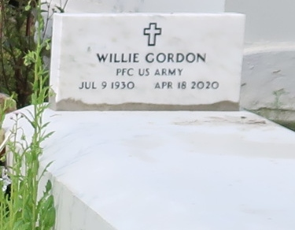
WILLIE GORDON
He passed away peacefully at East Jefferson Hospital in Metairie, on Saturday, April 18, 2020. He was 79.
Graveside Services with Immediate Family Members Only at Golden Wreath Cemetery in Lutcher, conducted by the Rev. Ferdinand Wallace, Jr.
Survived by his sons, Aaron (Laverne) Gordon, Eric Soniat, Kevin White, Tyran Martin and Wardell (Nicole) Cooper. A daughter Trienere Martin-Butler. A brother, Lawrence (Jacqueline) Gordon. Grandchildren, Arzelia (John) Smith, Jessica (Rydell) Gordon, Eric (Anita) Taylor, Shandon and Burnell Gordon and Kendell LeBray. A devoted friend, Addie Cooper, numerous nieces, nephews, cousins, other relatives and friends.
Preceded in death by his parents, James Gordon, Sr., and Mary Manuel Gordon. His wife, Dorolene Clark Gordon. His son, Eric Gordon. His daughter, Wanda Gordon. Sisters, Dorothy (Edwin, Sr.) Williams, Carrie Lee (Eli) Jackson, Lilly (Arthur, Sr.) Harper, and Lydia (Alvin) Turner. Brothers, James (Virginia) Gordon, Jr. and Rev. Herbert (Rose) Gordon.
BRAZIER-WATSON FUNERAL HOME IN CHARGE OF ARRANGEMENT. Visit us at www.brazierwatsoncom to sign our guest book.
Published by The Advocate (Baton Rouge, Louisiana)
from Apr. 21 to Apr. 22, 2020.

