Alexander Jackson, Sr.
March 6, 1926 - February 13, 2008

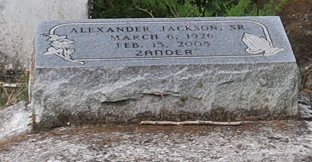

Alexander Jackson, Sr., at his residence in Lutcher, LA, at 7:00 a.m., Wednesday, February 13, 2008. Son of the late Andrew Jackson, Sr. and Rowenia Stewart Jackson. Husband of Augusta Garrett Jackson. Father and father-in-law of Theresa and Charles Washington, Catherine and Alvin Morton, Joyce and Alvin Washington, Paulette and Leroy Washington, Bertha Joseph, Bernadette Coleman, Dianna Honor, Kathleen and Chad Gautreaux, Wilbert and Glenda Diggs, Frank and Alana Diggs, James and Adline Jackson, Alexander Jr. and Peggy Jackson, Lloyd and Burnell Jackson and the late Andrew Jackson, Jr. Brother of Elnora Thirsty, Audrey Scott, Traviter Davis, Murvil Silas, Louisa Nunnery, Barbara Melancon, Doris and Catherine Jackson, Andrew Jackson, the late Alma Corbitt, Isabella, Dorothy, Mozella, Charles, Peter, James, James P., and Earl Holden. Stepson of the late Amadise Mitchell. Also survived by 51 grandchildren, 47 great-grandchildren, nieces, nephews, cousins, other relatives and friends. Age 81.
Visiting at Greater King Triumph Baptist Church, Lionel Washington, Street, Lutcher, LA, Saturday, February 23, 208 from 9:30 a.m. until Religious Services at 11:00 a.m. Conducted by the Rev. Reginald Joseph. Interment in Golden Wreath Cemetery, Lutcher, LA. BRAZIER-WATSON FUNERAL HOME in charge of arrangements.

Times-Picayune, The (New Orleans, LA)
Friday, February 22, 2008

