Roderick A. Johnson
December 9, 1957 – August 5, 2019

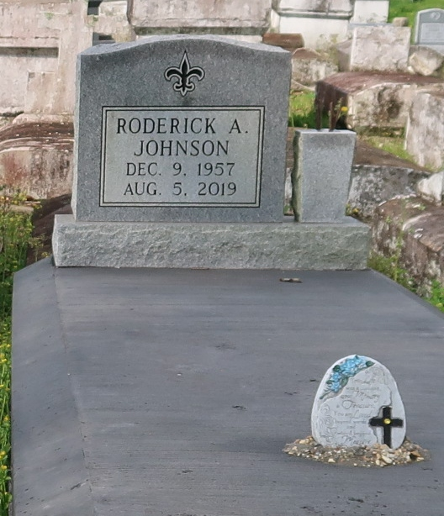
Roderick (Pokey) Johnson transitioned on Monday August 5, 2019, Husband of Betty Scott Johnson, Father of Keyonna Johnson, Tasha J, Washington, and Crystal J. Pidgeon. Roderick is also survived by grandchildren, brothers and sisters and a host relatives and friends.
Celebration Service will be held on Saturday August 17, 2019 at St. Mark B.C., LA, 132 Marques St. Mt. Airy, La at 10:00 am. Rev. Oscar Nelson officiating. Visitation on Saturday from 8 am until service time (ONLY) Interment Golden Wealth Cemetery, Lutcher, La. Professional Services entrusted to the caring staff Hobson Brown Funeral Home, 134 Daisy St. Garyville, La 70051. 985-535-2516
The Times-Picayune (New Orleans, Louisiana)
Aug. 15 to Aug. 17, 2019.

