Ethel (Lovette) Kennard
April 1, 1921 – February 10, 2004

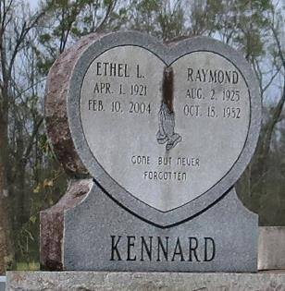
KENNARD, ETHEL LOVETTE
A native and resident of Gramercy, she died at her home at 9:35 a.m. Monday, Feb. 9, 2004. She was 82. Visiting at Greater Golden Grove Baptist Church, 127 S. Mulberry St., Gramercy, from 5 p.m. until religious service at 7 p.m. Friday, Feb. 13, 2004, conducted by the Rev. Dr. Herbert Gordon. Dismissal at 11 a.m. Saturday. Interment in Golden Wreath Cemetery, Lutcher. Survived by two sons, Adam Cooper Jr. and Darryl Kennard, both of Gramercy; a sister, Irma Joseph; three brothers and two sisters-in-law, Harold and Alma Goff, Gerald Goff and Donald and Marva Goff; 11 grandchildren, 27 great-grandchildren and numerous nieces, nephews, cousins, other relatives and friends. Preceded in death by her first husband, Adam Cooper Sr.; her second husband, Raymond Kennard; a brother, Albert Lovette Jr.; her parents, Albert and Viola Lovette; two grandsons; and her daughter, Marion C. Aubert. Brazier-Watson Funeral Home in charge of arrangements.
Advocate, The (Baton Rouge, LA)
Friday, February 13, 2004

