Velma (Stewart) Lee
March 27, 1922 – July 27, 2002

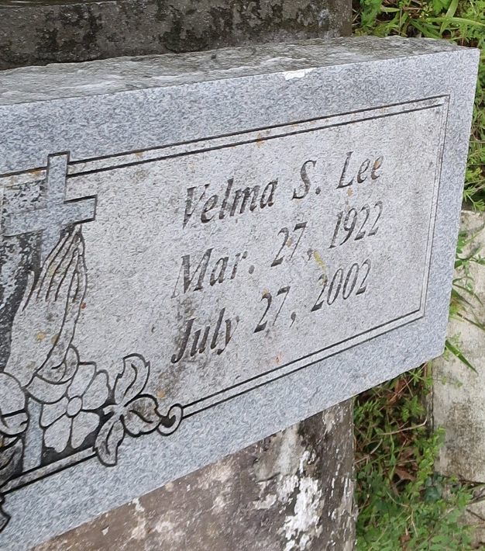
GRAMERCY - Velma Stewart Lee, 80, a native of Mt. Airy and resident of Lutcher, died July 27. She was the mother of Doris Johnson and Manuel Jr., Vernon, Noel and James Lee.
She was the daughter of the late Eddie and Aldonia Luke Stewart and sister of Ethel Jackson, Alice Alexis, Gloria Davis, Willie Mae Taylor, Geneva Long, Eddie and Milton Stewart and the late Dorothy Knight, Eura Lee Porter and Raymond and Melvin Stewart. She is survived by 13 grandchildren and 15 great-grandchildren and was preceded in death by one grandchild.
Services were Aug. 2 at Greater Golden Grove Baptist Church, Gramercy, with interment at Golden Wreath Cemetery.
L'Observateur, La Place, LA
Tuesday, August 6, 2002

