Morris C. Louis
January 3, 1918 – March 15, 1991

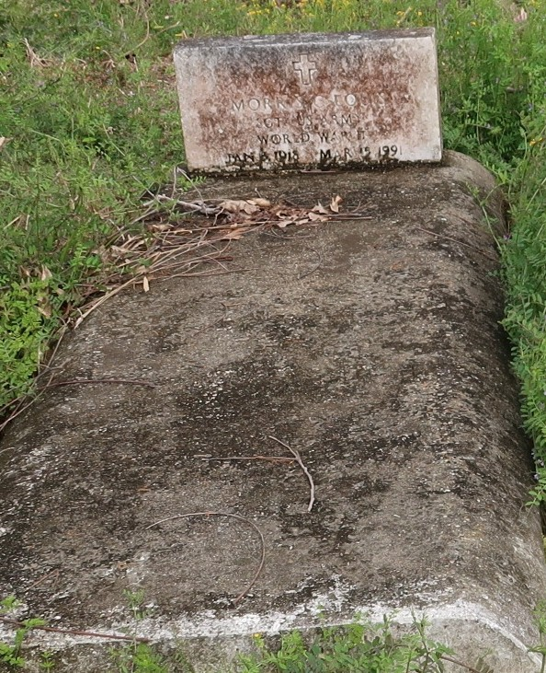

Wake and religious services will be held at 8 p.m. Wednesday at New Zion Baptist Church in Gramercy for Gramercy native and resident Morris "Khaki" Louis, 73, who died 3:25 p.m. Friday.Dismissal will be 10 a.m. Thursday and burial will follow at the Golden Wreath Cemetery in Lutcher.Louis was the father of Joyce Ann Fluence, Gramercy, Julia Louis, Paincourtville, Shirley Williams, River Ridge and Stf. Sgt. Morris Louis Hawkins, Detroit, Mich; brother of Gladys, Ethel and Florence; grandfather of seven and great grandfather of one.

Unknown source
Mar. 15, 1991
Contributed by Veronica Sampey

