Fred Perkins Jr.
July 13, 1946 – February 22, 2005

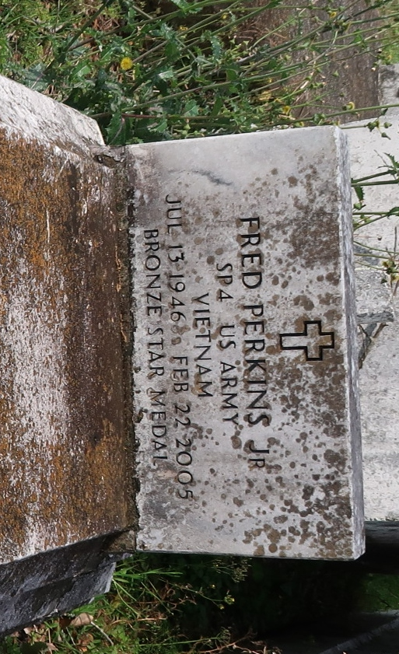
LUTCHER - Fred Perkins Jr., 58, a native and resident of Lutcher, died Feb. 22.
He was the former husband of Betty Perkins and father of Shawn Bourgeois, April Washington, Monica Williams, Tharnell and Shannon Washington. He is also survived by 11 grandchildren and one great-grandchild.
Services were March 4 at Israelite Baptist Church, Lutcher, with interment at Golden Wreath Cemetery, Lutcher.
L'Observateur (La Place, LA)
Monday, March 7, 2005

