Debra Doopay (Ursin) Robertson
October 18, 1953 – December 12, 2006

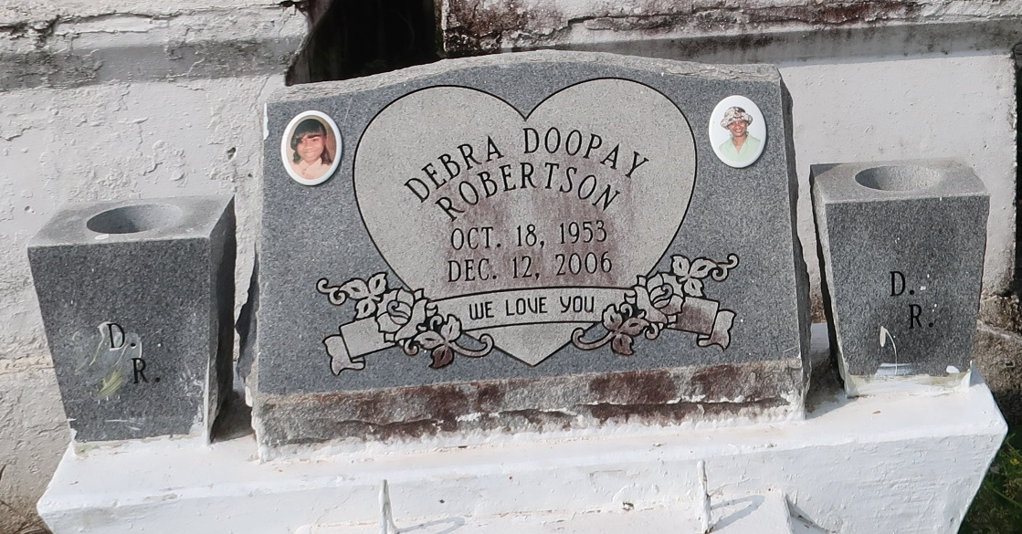
A native of Lutcher and a resident of Geismar, she died at 6:21 p.m. Tuesday, Dec. 12, 2006, at St. Elizabeth Hospital in Gonzales as a result of an automobile accident. She was 53. Interment in Golden Wreath Cemetery, Lutcher.
She is survived by her husband, Albert Robertson Sr. of Geismar; two daughters, Dianthe West and Niya West Joseph; two brothers, Wilbert Ursin Jr. and wife Dari Ann and Elvin Davis; aunt, Glendoris Watson; nine grandchildren; stepson, Albert Robertson Jr.; numerous nieces, nephews, cousins, other relatives and friends. Preceded in death by her parents, Wilbert Ursin Sr. and Ernestine Shiloh Ursin; two sisters, Emma Jean Franklin and Iris Davis; two brothers, Willie Ursin Sr. and Wilfred Ursin; nephew, Tierre Tyler; and great-nephew, Kyron Franklin.

Gonzales Weekly Citizen (Ascension Parish, LA)
Wednesday, December 27, 2006

