Edward Smith Sr.
September 23, 1930 – July 22, 2000

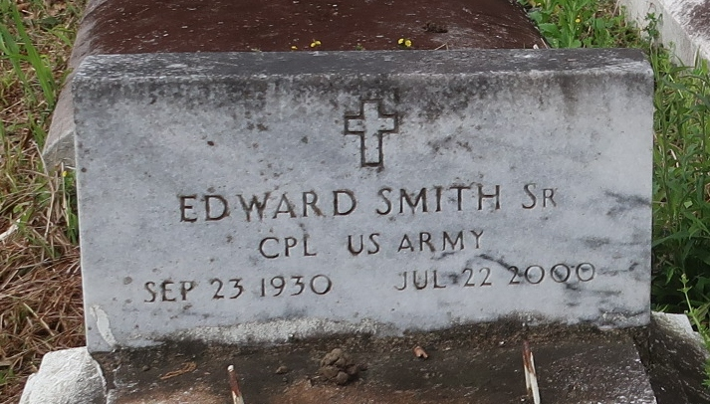
LUTCHER - Edward Smith Sr., 69, a native of Gonzales and resident of Lutcher, died July 22. He was the father of Joyce Dear and Eula Smith. He was also the brother of Doretha Williams, Jessie Mae Jacque, McKinley, Wilbert, Charles and Clarence Smith and Eugene and Allen Stalk. He is also survived by 10 grandchildren and nine great-grandchildren.
Services were July 31 at King David Baptist Church, Lutcher, with interment at Golden Wreath Cemetery, Lutcher.
L'Observateur (La Place, LA)
Wednesday, August 2, 2000

