Allissha Shirrell Stark
November 10, 1975 – October 7, 2005

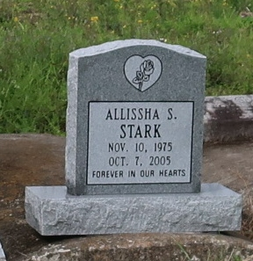
A native and resident of Lutcher, she died at 2:24 p.m. Friday, Oct. 7, 2005, at St. Elizabeth Hospital in Gonzales. She was 29. Visiting at Mount Olive Baptist Church, 3143 La. 642, Paulina, on Saturday, Oct. 15, from 9:30 a.m. until religious service at 11 a.m., conducted by the Rev. Elmo Lee. Interment in Golden Wreath Cemetery, Lutcher.
Survived by her parents, Allen Stark Sr. and Joann Harris Stark of Lutcher; sister, Altreca Shawntrell; brothers, Allen Stark II and Tyrus Harris; maternal grandmother, Laura Johnson; companion, Demond Miller; best friend, Heidi Taylor; niece, Tamia Johnson; nephew, Allen Stark III; aunts, Linda Allen, Tammie Jones, Doretha Williams, Jessie Mae Jacque, Ceily Smith, Bonnie Stark and Lettie Richardson; uncles, Reginald Allen, Darryl Jones, Lionel Harris, McKinley and Wilbert Smith and Eugene Stark; cousins, other relatives and friends.
Preceded in death by her grandparents, Emma Richardson and Eugene Stark Sr. and Leslie Harris; and uncles, Leroy, Leon and Leslie Harris Jr., Edward Smith Sr. and Joseph Richardson. Brazier-Watson Funeral Home, Donaldsonville, is in charge of arrangements.

Advocate, The (Baton Rouge, LA)
Friday, October 14, 2005

