Joanne (Harris) Stark
February 20, 1952 – October 9, 2021

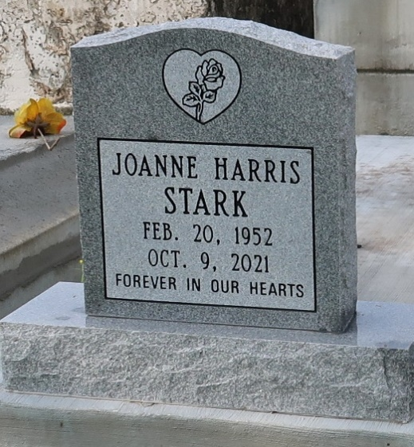
Joanne Harris Stark, a native of Baton Rouge and a resident of Lutcher. She passed away peacefully at her home in Lutcher, on Saturday, October 9, 2021 at the age of 69. A Walk Thru Public Visitation will be held at Mt. Olive Baptist Church, 3143 LA 642, Paulina, Saturday, October 16, 2021 from 9:30 a.m. to 10:45 a.m. followed by Religious Services at 11:00 a.m., conducted by the Rev. Oscar Nelson. Interment in Golden Wreath Cemetery in Lutcher. Masks and Social Distancing Will Be Required At All Times.
Survived by her devoted husband, Allen Stark. Her daughter, Dr. Altreca (Theodore) Bourne. Son, Allen (Telisha) Stark, II. Sisters, Tammy (Darryl) Jones and Linda Allen. Brother, Lionel (Lois) Harris. 5 grandchildren, Sisters-in-law, Jessie Jacque, Lattie Richardson and Maude Ann Harris. Brother-in-law, Eugene (Bonnie) Stark. Her aunt, Helen Sheppard, numerous nieces, nephews, cousins, other relatives and friends. Preceded in death by her parents, Leslie Harris and Laura Sheppard Harris. Her daughter, Allissha Stark. Brothers, Leslie Harris, Jr., Leon and Leroy Harris. Sister-in-law, Doretha Williams. Brothers-in-law, Levi Allen, McKinley Smith, Ed Smith, Wilbert Smith, and Joseph Richardson. Brazier-Watson Funeral Home in Charge of Arrangements. Visit us at www.brazierwatson.com to sign our guest book.

Advocate, The (Baton Rouge, LA)
Thursday, October 14, 2021

