Teresa Monique (Sims) Ursin
October 23, 1971 - April 22, 2004

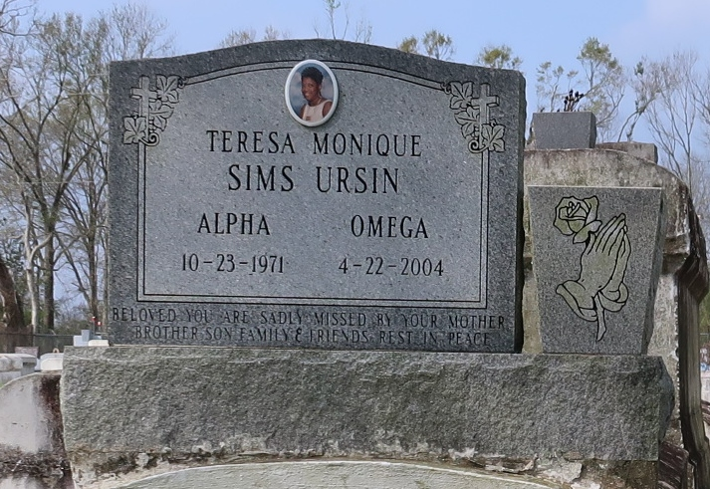
Teresa Monique Sims Ursin, a day-care teacher with Angel Wings Learning Academy, died April 22 of complications from asthma at her home. She was 32. Mrs. Ursin was a lifelong resident of New Orleans. She was a graduate of Alcee Fortier Senior High School. She was a former employee of Wendy's Restaurant and Nettles Academy. She was a member of Mount Rock Baptist Church.
Survivors include a son, Eldridge Ursin Jr.; her father, Milton Sims Sr.; her mother, Barbara Ann Sims; and a brother, Milton Sims Jr.
A funeral will be held Saturday at 10 a.m. at Mount Rock Baptist Church, 9137 Edinburgh St. Visitation will begin at 9 a.m. A dismissal service will be held at 12:30 p.m. at Greater King Triumph Baptist Church, 2572 Lionel Washington St. in Lutcher. Burial will be in Golden Wreath Cemetery. Duplain W. Rhodes Funeral Home is in charge of arrangements.
Times-Picayune, The (New Orleans, LA)
Thursday, April 29, 2004

