Bernice Washington
February 7, 1932 – November 21, 2001

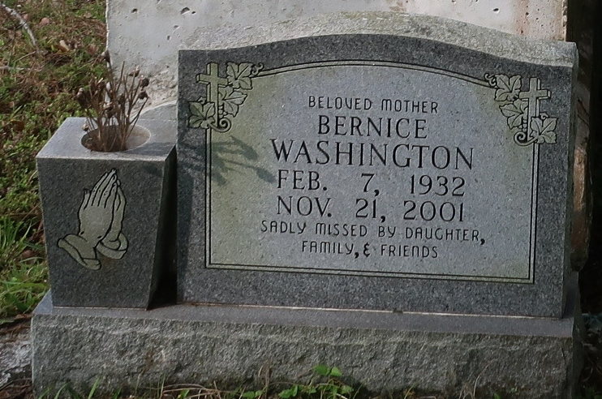
Bernice Washington, a retired laundry worker, died Wednesday of kidney and respiratory failure at Memorial Medical Center. She was 69. Ms. Washington was born in Springfield and lived in Lutcher for the past 60 years. She attended school in St. James Parish. She was employed as a laundry supervisor at Charity Hospital for 36 years. She was a member of the Magnolia Blossom J.F.P. No. 3544 and the Grand Temple Daughter of Elks I.B.P.O.E. and Winter Capitol Temple No. 42.
Survivors include a daughter, Barbara Sims; three brothers, Charles Bowser and Anthony Johnson of New Orleans, and Dennis Washington of Reserve; two sisters, Mildred Albert and Onetta Washington of Lutcher; two grandchildren; and a great-grandchild.
A funeral will be held Saturday at 9 a.m at Majestic Funeral Home, 1833 Oretha Castle Haley Blvd. Dismissal will be at 11 a.m. at Greater King Triumph Baptist Church in Lutcher. Burial will be in Golden Wreath Cemetery.
Times-Picayune, The (New Orleans, LA)
Thursday, November 29, 2001

