Katherine (Favorite) Williams
August 7, 1962 – November 27, 2007

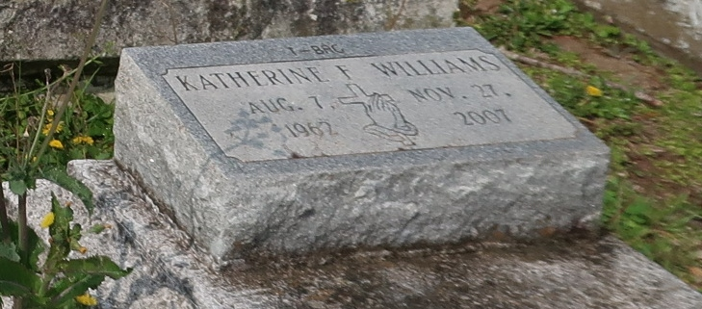
A native and resident of Lutcher, Catherine Favorite "T-Bag" Williams died Tuesday, Nov. 27, 2007, at her residence. She was 45.
Visiting at King Solomon Baptist Church, Lutcher, until religious service conducted by the Rev. Benjamin Scott. Interment in Golden Wreath Cemetery, Lutcher.
She is survived by two sisters, Joyce Anderson and Audrey Jackson; brother, Herbert Favorite Jr.; brother-in-law, Robert Jackson Sr.; sister-in-law, Annie Favorite; nieces, nephews, cousins, aunts, uncles, godchildren, other relatives and friends.
Preceded in death by her mother, Augustine Favorite; a brother, Alton Lewis; and maternal grandparents.
Arrangements by Brazier-Watson Funeral Home, Donaldsonville.
The Advocate, Baton Rouge, LA; December 3, 2007
Contributed by Jane Edson

