Eunice (Narcisse) Alexander
January 10, 1927 – June 27, 2003

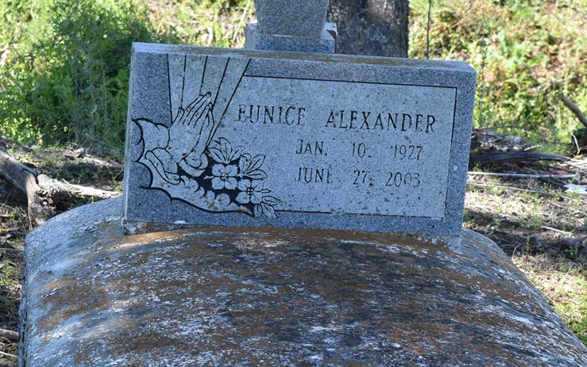

Eunice Alexander of Wallace, LA on Friday, June 27, 2003 at Riverlands Health Care. Daughter of the late Anna and Rudolph Narcisse. Wife of the late Rev. Floria Alexander. Mother of John Stewart (Betty) of St. James, LA, Anna Mae Julien (John), Wallace, LA, Carolyn Johnson (Milton), Vacherie, LA, Mary Louise Henderson (Steve), Inglewood, CA, Joyce A. Joseph, Northridge, CA, Linda Farlough (Herman), Lutcher, LA, Pathernilla Alexander, Carson, CA, the late Michael Alexander and Shirley Mae Stewart. Sister of Mary Albert, Jeanette Sanders, Vanilla Johnson, Rudolph Narcisse, Cusey Narcisse, the late Florence Williams, Agnes Robertson, Justillien and Cubert Narcisse. Also survived by 15 grandchildren, 12 great-grandchildren, a host of nieces, nephews, sisters- and brothers-in-law, other relatives and friends. A native and resident of Wallace, LA. Age 76 years.
Relatives and friends of the family; also pastors, officers and members of the Highway B.C., 1st Baptist Church and neighboring churches; and employees of Riverlands Heath Care are invited to attend the Funeral Services on Saturday, July 5, 2003 at 11:30 a.m. from the Highway B.C., Vachiere, LA. Rev. Wesley Brown - officiating. Interment 2nd Highway B.C. Cemetery, South Vacherie, LA. Visitation at the Church after 9:00 a.m. on Saturday. THE BALONEY FUNERAL HOME in charge of arrangements.
Times-Picayune, The (New Orleans, LA) - July 4, 2003

