Za’Nyri A’shie Anderson
December 18, 2012 – February 15, 2013

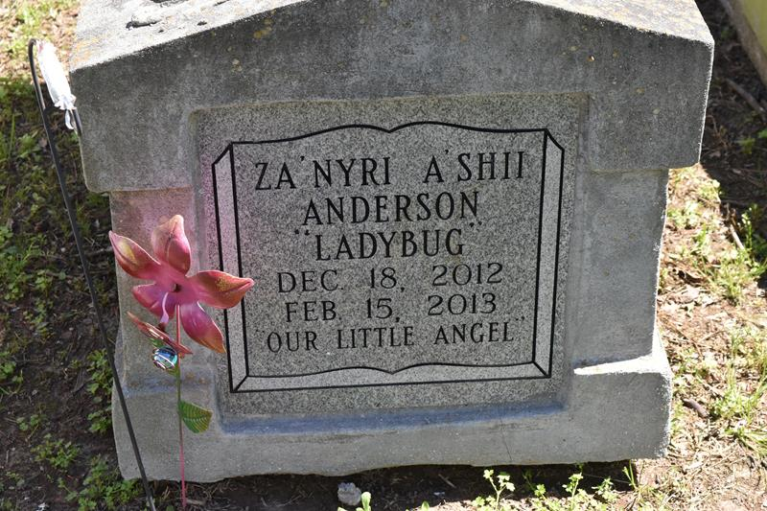

Za'Nyri A'Shii Anderson, infant, a native and resident of Vacherie, died Friday, Feb. 15, 2013.
A graveside service and burial will be at 11 a.m. Friday at Greater Deliverance Full Gospel Ministries Cemetery in Vacherie.
She is survived by her mother, Renasia Anderson; father, DeShaun Aguillard; sister, Da'Nasia Aguillard; and grandparents, Dwayna Williams, Anthony Williams Sr., Hattie Moses and Perry Aguillard. She was preceded in death by her grandfather Norman Hampton Jr.
Kennedy Funeral Home in Raceland is in charge of arrangements.
Houma Today (Terrebonne Parish, LA)
Feb. 19 to Feb. 20, 2013

