Gail Marie (Smith) Comminie
February 13, 1953 - June 8, 2020

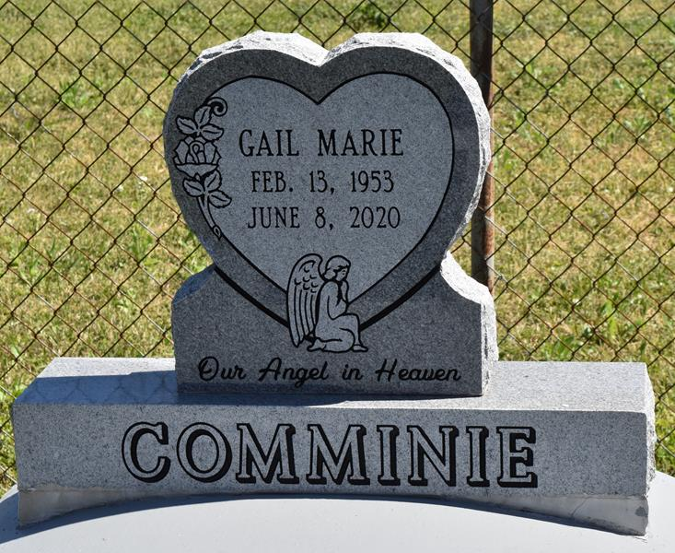

Gail Marie Smith Comminie, resident of Edgard, LA transitioned to her Heavenly Home on Monday, June 8, 2020 at Ochsner Medical Center in Kenner, LA. Gail was born on February 13, 1953 to Jessel and Eunice Samuel Smith of Edgard, LA.
She graduated from Second Ward High School in 1971. Gail was joined in Holy Matrimony on May 1, 1971 to Rev. Joseph Comminie Jr. From their union 4 children were born, Tammy Lynette Gullage, Shantel Comminie (Shannon) Octave, Joseph (Mtisa) Comminie III, and Jamaal Anthony (Ranada) Comminie. Gail also had 11 grandchildren (Anastasia, Leonard Jr., Larenz, Shannon Jr, Shayler, Jeremiah, Jamaal Jr, Ja'Quan, Danasha, Syan, and Randall) and 1 great-grandchild (Aubrie).
Gail was an active member of Greater New St. Peter Baptist Church in Edgard, LA where she was a Deaconess, Sunday School Teacher and Vacation Bible School Teacher. She also wrote numerous skits and plays for the church, which were performed all over the River Parishes and local areas. Gail enjoyed writing, ever since she was a young girl. She wrote a weekly column for the Times-Picayune newspaper for many years. She finally realized her dream and became a published author. Her two books are "Still Have a Praise" and "Can You See the Stress? I Do Now." She was recently nominated for the Christian Literacy Award. Gail enjoyed gardening and regularly showed off her flowers and vegetables. She also collected figurines and her collection continued to grow year after year. When she wasn't writing, gardening, or collecting, she was making sure she kept an immaculate house.
Gail leaves to cherish her memories her husband of 49 years, Rev. Joseph Comminie Jr., her 4 children, Tammy, Shantel, JJ and Jamaal, her son-in-law, Shannon, her daughters-in-law, Mtisa and Ranada, her brothers, Terry (Denine), Keman (Kattie) and Donald (Lisa) Smith, sisters, Linda Dumas, Monna (Timothy) Green, and Yolanda Johnson, and a host of nieces, nephews and extended family.
Gail is preceded in death by her parents, Jessel and Eunice Smith, her brother Jessel Smith Jr., and her in-laws, Joseph and Leanna Favorite Comminie.
Relatives and friends of the family are invited to view on Saturday, June 13, 2020 from 9:00 a.m. - 11:00 a.m. at Treasures of Life Funeral Services, 315 E. Airline Highway, Gramercy, LA 70052. Interment will follow at Greater Deliverance Second Baptist Church Cemetery, Vacherie, LA.
Treasures of Life Funeral Services, Gramercy, LA

