Pauline (Keller) Dumas
July 20, 1927 – February 8, 1998

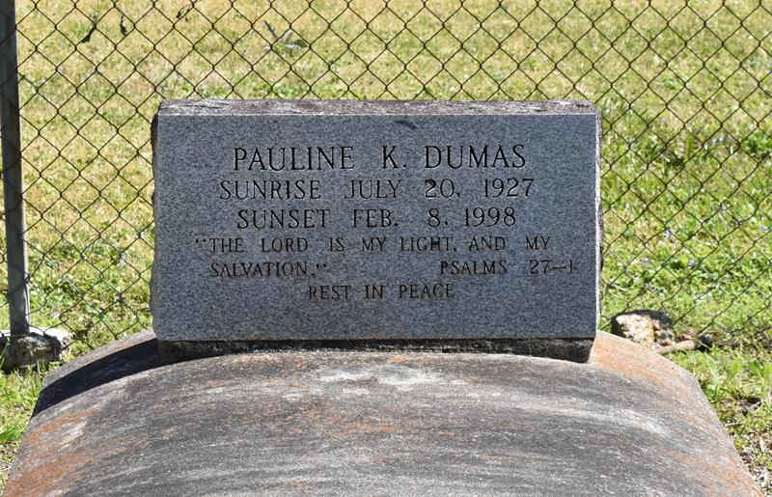

Pauline Keller Dumas, a retired chef, died Sunday of a heart attack at West Jefferson Medical Center. She was 69. Mrs. Dumas was born in Vacherie and lived in Marrero for the past 30 years.
Survivors include a son, Dennis Dumas; four daughters, Theresa Matthews Plummer, Judy Rains, Catherine Washington and Jacquelyn Lovelace; four brothers, Garfield, Alex, Alvin and Louis Keller Sr.; two sisters, Rosalie Joseph and Lubertha Allen; 11 grandchildren; and five great-grandchildren.
Visitation will be today from 9 a.m. to noon at Davis Mortuary, 6820 West Bank Expressway, Marrero. A funeral will be held Saturday at 10 a.m. at Greater St. Stephen Full Gospel Baptist Church, 2308 S. Liberty St. Burial will be in Second Baptist Church Cemetery in Vacherie.
Times-Picayune, The (New Orleans, LA)
Friday, February 13, 1998

