James M. Gros Sr.
December 30, 1955 – April 12, 2003

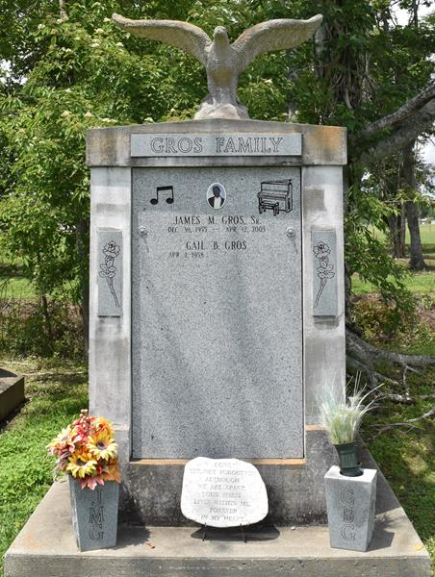

James M. Gros, Sr. of Vacherie, La. on Sat., April 12, 2003 at Ochsner Foundation Hospital. Son of the late Pershing Gros, Sr. and Loretta Keller Gros. Husband of Gail Baptiste Gros. Father of James Gros, Jr., Anitra Gros, guardian of Michael Gros. Brother of Geraldine G. Oubre, Lorraine G. Every, Romona G. Bordelon and Loretta Gros of Texas, Nathaniel Gros of Germany, Malcolm Gros of Texas, Billard and Emile Gros of Vacherie, La. Grandfather of Kayla and Cherish. Son-in-law of Anita H. Baptiste. Godchild of Elizabeth Laurent. Also survived by (6) sisters-in-law, (5) brothers-in-law, a host of aunts, uncles, nieces, nephews, cousins and friends. Preceded in death by siblings Pershing Jr., Gerald, Lamont and Camille Gros, grandparents and father-in-law Sidney Baptiste, Sr. A native and resident of Vacherie, La. Age 47 years.
Relatives and friends of the family, also pastor, officers and members of the Greater Deliverance Full Gospel B.C., First Baptist Church and neighboring churches, employees of St. James Youth Center and St. James Parish School System, Goodchildren Society are invited to attend the funeral services on Saturday, April 19, 2003 at 12:00 noon from the First Baptist Church, Vacherie, La. Rev. Lucien Garrett, Pastor, Elder Eddie Narcisse officiating. Interment 2nd Baptist Church Cemetery, So. Vacherie, La. Visitation on Saturday from 8-10AM from the Greater Deliverance Full Gospel Church, So. Vacherie, La. after 11:00 AM at First Bapt. Church in Vacherie. The Baloney Funeral Home in charge of arrangements.
Times-Picayune, The (New Orleans, LA) - Apr. 18, 2003

