Beatrice (Lemieux) Harris
November 9, 1924 – July 13, 2004

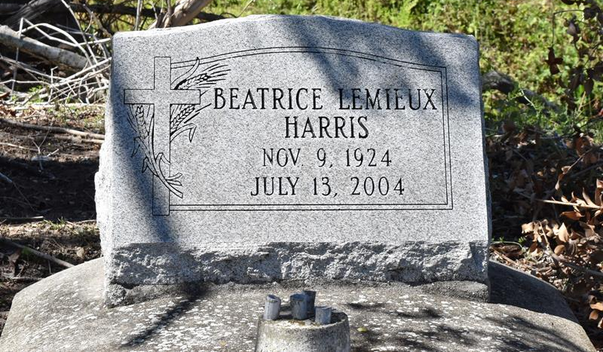

Beatrice Lemieux "Bea" Harris on Sunday, July 11, 2004. Daughter of the late Willie Sr. and Rosalie Lemieux. Wife of the late Norman Harris. Mother of Perry Duskin, Sr. of Marrero, LA, Larry, Rosalie Harris Pete and Master Sergeant Jerome Harris of San Antonio, Texas. Sister of Gussie Stevens, the late Sedonia Tillman, Elsie Dumas, Ocelia Wingate, Lucretia Keller, Elnora Jones, Willie, Gabriel and Alexander Lemieux. Mother-in-law of Barbara Duskin of Marrero, LA, Mary, Henry Pete and Judy of San Antonio, Texas. Also survived by a host of nieces, nephews, relatives and friends.
Relatives and friends of the family; pastors, officers and members of King Solomon Baptist Church, Second Baptist Church, St. Mary's Missionary Baptist Church, Bethal AME, Firehouse Family Ministries; employees of Crown Plaza Hotel, Keller Air Force Base, Ed-U-Care, San Antonio Independence School District, Orleans Parish Deputy Sheriff, Jefferson Parish Corectional Center and Wal-Mart are invited to attend the Wake Service held on Sunday, July 18, 2004 at 6:00 p.m. at King Solomon Baptist Church, 2610 Andry St. Visitation will begin at 4:00 p.m. Interment will be held at 11:00 a.m. on Monday, July 19, 2004 in Second Baptist Church Cemetery, Vacherie, LA. Arrangements by DUPLAIN W. RHODES FUNERAL HOME, 3933 Washington Ave.
Times-Picayune, The (New Orleans, LA) - Jul. 18, 2004

