Willie Hobdy
September 18, 1945 – July 4, 2001

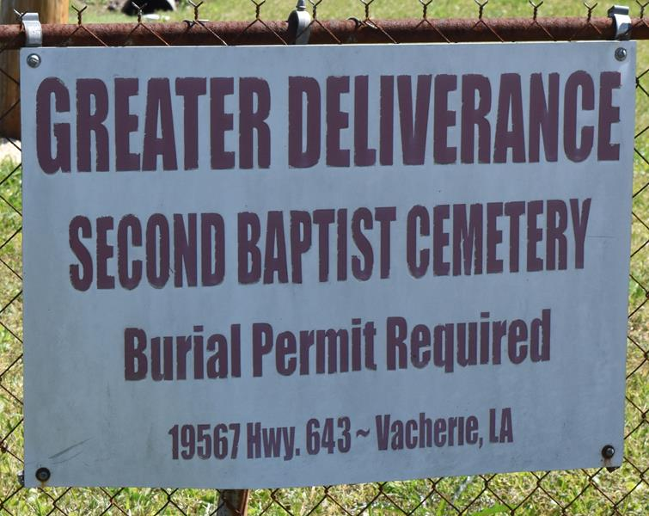

GARYVILLE - Willie Hobdy, a resident of Vacherie, died July 4. He was the husband of Ann Hobdy and father of Janice, Sharon, Willie Sam, Kwanda Evans, Arthur Wallace, Lucille King and Willie Dese. He was also the son of the late Lucille Hobdy and brother of Beatrice, Henry, Desire, Milton and the late Vivian Philip. He is also survived by 24 grandchildren and three great-grandchildren.

Services are today at 2 p.m. in the chapel of Baloney Funeral Home, Garyville, with interment at Second Baptist Cemetery, Vacherie. Visitation starts at 1 p.m.

L’Observateur, LaPlace, Louisiana
July 7, 2001

