Ernest Lucas James
April 1, 1929 – February 18, 2010

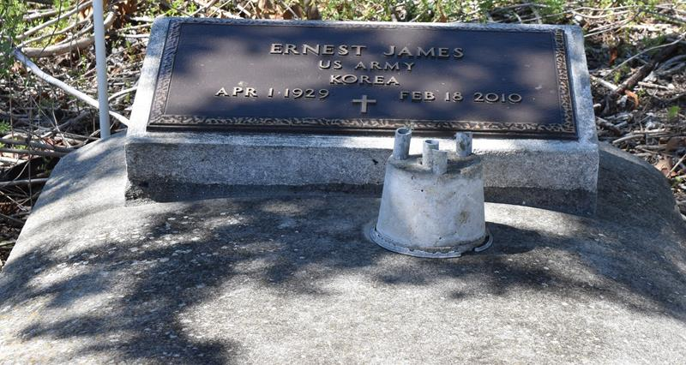

Ernest Lucas James departed this life on Thursday, February 18, 2010 at West Jefferson Medical Center. Father of Michael Landry, Sr. and the late Eric Brinkley. Son of the late Rev. Solomon and Julien James. Brother of Almedia London and the late Mary Dumas, Beulah Jumpiere, and Samuel James. Also survived by 1 grandson, 2 great- grandchildren and a host of nieces, nephews, cousins, other relatives and friends. Age 80 years, a native of Vacherie, La. and a resident of Harvey, La.
Relatives and friends of the family, also pastors, officers, and members of Mt. Olive, King Solomon, Israel, Shiloh and Mt. Pilgrim Baptist Churches and neighboring churches are invited to attend the Funeral Service at Mt. Pilgrim Baptist Church, 922 Estalote Ave., Harvey, La., on Saturday, February 27, 2010 at 9:30a.m. Rev. Ricky Johnson-officiating. Visitation will begin at 8:30a.m. Interment: Second Baptist Church Cemetery-Vacherie, La. Arrangements by Davis Mortuary Service 230 Monroe St. Gretna, La.

Times-Picayune, The (New Orleans, LA) - Feb. 26, 2010

