Bernetta (Favorite) Jasmin
November 7, 1932 – May 30, 2002

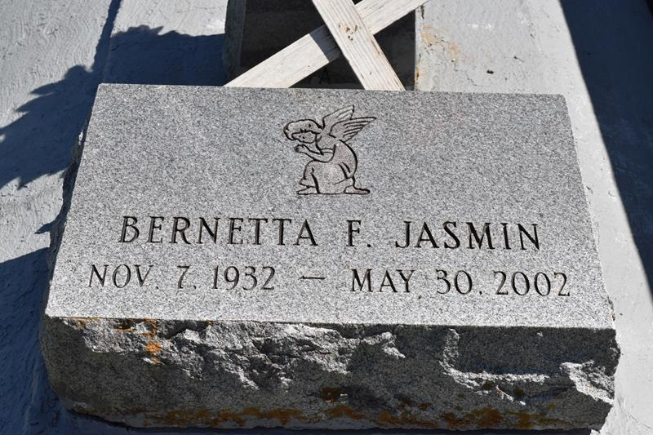

Bernetta Favorite Jasmin of Edgard, LA. on Thursday, May 30, 2002 at St. James Hospital. Age 69 years. Wife of the late Rasby Jasmin. Mother of Troy (Cynthia) Jasmin. Step-mother of Pamela Simon. Grandmother of Troy Lynn and Jamar Jasmin. Daughter of the late Samuel and Virginia Favorite. Sister of Vivian Chopin, Josephine Favorite, Shirley Grows, Marion Lewis and Larry Favorite of Edgard, LA., Anna Lewis of Marrero, LA., Leotha Perkins, Geraldine Boose and Margaret Henderson of New Orleans, LA. C.J. Favorite of Harvey, LA. and the late Joseph Favorite, Sr., Samuel Favorite, Jr., Bernice and Mary Ann Favorite, also survived by (6) sisters-in-law, (8) brothers-in-law, (3) aunts, (2) uncles and a host of nieces, nephews, cousins, other relatives and friends. A native and resident of Edgard, LA.
Relatives and friends of the family, also pastor, officers and members of the Greater New St. Peter B.C., 2nd African B.C. and neighboring churches, employees of Logistics Express, are invited to attend the funeral services on Monday, June 3, 2002 at 11:00 A.M. from the Greater New St. Peter B.C., Edgard, LA. Rev. Vernon Alexander, officiating. Interment 2nd Baptist Church Cemetery, South Vacherie, LA. Visitation at the church after 9:00 A.M. THE BALONEY FUNERAL HOME in charge of arrangements.
Times-Picayune, The (New Orleans, LA) - Jun. 2, 2002

