Jerry D. Joiner
December 26, 1947 – July 3, 2014

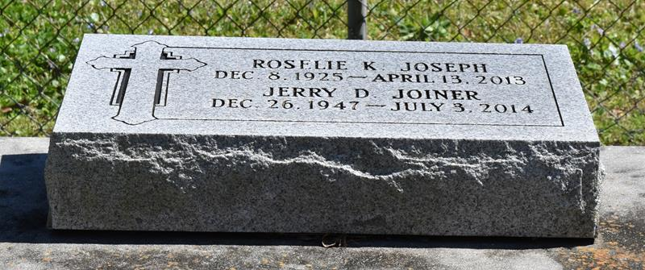

Jerry D. Joiner, a native of New Orleans and a long-time resident of Vacherie, LA, passed away on Thursday, July 3, 2014, at the age of 66. Jerry was a retired employee of Shamrock Construction. Son of the late Rosalie K. Joseph. He is survived by Chandra, Justice and Robovin Hunt and Gary Hilton of New Orleans, LA; Nephew of Mary Lubertha Allen of Wallace, LA, Louis Keller of Shreveport, LA, Elix Keller Sr. and Gufielle Keller of Vacherie, LA; Special cousin, Robert Harry of Vacherie, LA; Godfather of Regan Kelle, Sr. of Vacherie, Noel Allen of Gretna and Keisha Powell of New Orleans, LA. Also survived by a host of other relatives and friends.
Relatives and friends of family are invited to attend the Funeral Service at Rhodes Chapel, 3933 Washington Ave., on Saturday, July 19, 2014, at 1:30 pm. Visitation will begin at 12:30 pm; Elder Eddie E. Narcisse of Greater Deliverance Full Gospel Ministries of Vacherie, LA, officiating. Interment: Private. Arrangements by Rhodes, 3933 Washington Ave.

The New Orleans Advocate (LA); Jul. 15 to Jul. 19, 2014

