Roselie (Keller) Joseph
December 8, 1925 – April 13, 2013

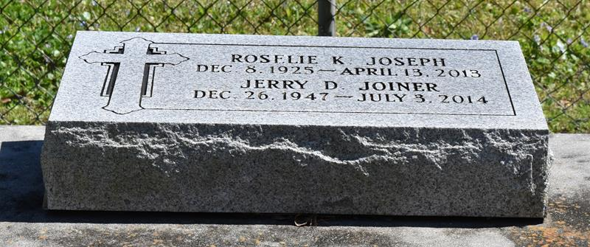

Rosalie Keller Joseph departed this life on Saturday, April 13, 2013 at her residence in Vacherie, LA at the age of 87. Daughter of the late Noel and Lubertha James Keller; Beloved wife by 2nd marriage to the late Rev. Alfred Joseph and by her first marriage to the late Clyde Joiner; Devoted mother of Jerry Joiner; Loving sister of Mary Allen, Louis, Sr., Gufielle and Elix Keller, Sr.; Sister in law of Geraldine, Audrey, and Equilla Keller; Grandmother of Chandra Hunt; Also survived by a host of nieces, nephews, godchildren, great grandchildren, a great great grandson, other relatives and friends.
Relatives and friends of the family, also members of Good Children Benevolent Society and neighboring churches are invited to attend the Homegoing Celebration at First Baptist Church, 1244 Magnolia Heights Street, Vacherie, LA on Saturday, April 20, 2013 at 11:00 am; Visitation will begin at 9:00 am; Rev. Johnnie Magee, officiating; Interment: Greater Deliverance Baptist Church Cemetery, Vacherie, LA; Arrangements by DW Rhodes, 3933 Washington Ave.

Times-Picayune, The (New Orleans, LA) - Apr. 15 to Apr. 19, 2013

