Alvin Keller
March 3, 1940 – April 24, 1999

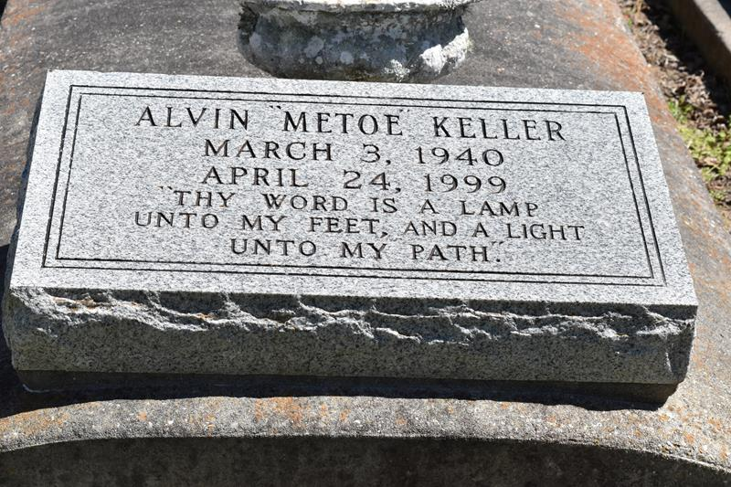

Alvin "Metoe" Keller, 59, a native and resident of Vacherie, died April 24. He was the son of the late Noel and Lubertha James Keller and brother of Rosalie Joseph, Mary "Lubertha" Allen, Elix, Louis and Gufielle Keller and the late Noelle Becnel, Loretta Gros, Melvina Jackson, Pauline Dumas, Armond Bernard and Johnny Keller.
Services at Second Baptist Church, Vacherie, with interment at the church cemetery.
L'Observateur, LaPlace, Louisiana - April 28, 1999

