Starlight Sharon Lemieux
March 22, 1980 – December 12, 2015

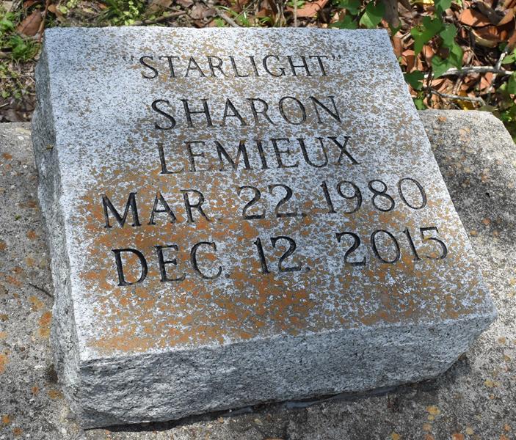

A resident of Baton Rouge and native of Houma, La passed away at Riverland Hospital in Ferriday, La at the age of 35.
Visitation Religious services Tuesday Dec 29, 2015 at Greater Deliverance Full Gospel Ministry 13890 Spruce St. Vacherie, La 9 a.m. until 11 a.m. religious service. Interment Church Cemetery.
Sharon is survived by three children, sisters, aunts, uncles, nieces, nephews other relatives and friends. Funeral Director Bernadien Poole, Professional Services Entrusted to Wesley Funeral Home, Plaquemine, La.
The Advocate, Baton Rouge, Louisiana; Dec. 26 to Dec. 28, 2015

