Eddie E. Narcisse Sr.
May 31, 1948 – December 10, 2017

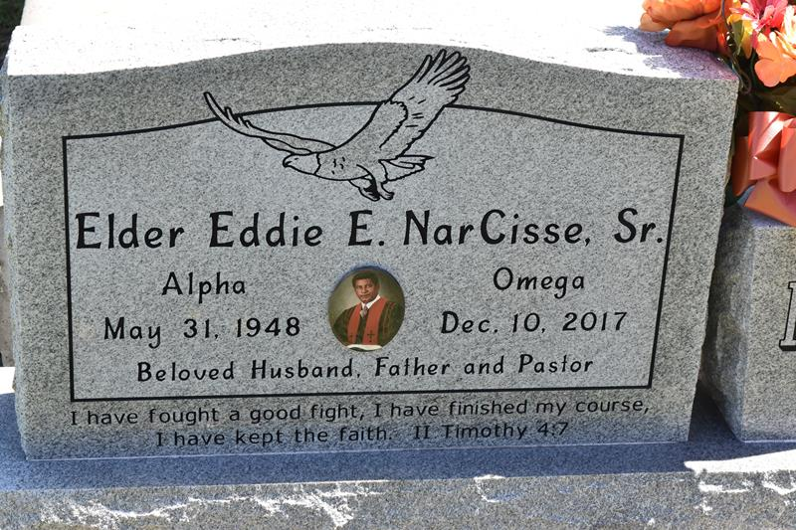

On Sunday, December 10, 2017, Elder Eddie E. Narcisse Sr., surrounded by his family, went to be with the Lord. Elder Narcisse was an influential spiritual leader in the pulpit and silent architect providing counsel from Maryland to California for all in need. After serving his country in the United States Army, Eddie was a dedicated employee of the United States Postal Service for 43 years. He also went on to achieve a Doctor of Divinity from Saint Luke Evangelical School of Biblical Studies.
After retirement from the postal service, Eddie faithfully served his community through spiritual leadership as head of Greater Deliverance Full Gospel (formerly Greater Second Baptist Full Gospel) in South Vacherie, Louisiana for 37 years.
Elder Narcisse was ingrained deeply in his community through support of the St. James School Board, Sheriff's Department, League of Better St. James, and providing weekly bible study articles in The Enterprise newspaper (Vacherie, LA).
Elder Narcisse is survived by his devoted wife, Adrial D. Narcisse, children Allana Narcisse, Gwen Crump-Perkins, Nicole Narcisse Sterling (Jamal), Marquita Narcisse, Eddie Narcisse Jr., Andrea Narcisse, and David Narcisse. He also leaves a host of grandchildren, great grandchildren, sisters, brothers, church family and community members to rejoice in his memory. He was preceded in death by his parents, Joseph and Rosalie Louis Narcisse, his sister, Victoria Mallet, daughter, Trinette Jordan and son, Lowell "Billy" Narcisse.
All are invited to attend a gathering of family and friends on Friday, December 15, 2017 from 4:00-6:00 PM at Treasures of Life Funeral Services, 315 E Airline Hwy, Gramercy, LA 70052. His homegoing services will be on Saturday, December 16, 2017 from New Hope Family Worship (Greater Grace), 21490 State Hwy 20, Vacherie, LA 70090, Pastored by Claudette Aubert; Bishop Charles Wallace-Officiating. Visitation 9:00 AM followed by service at 12:00 PM. Interment Greater Deliverance Cemetery, Hwy 643, Vacherie, LA.; Repast following the services at Good Children Hall, 19515 Highway 643, Vacherie, LA.
The Advocate, Baton Rouge, Louisiana; Dec. 14 to Dec. 16, 2017

