Judy A. (Dumas) Raines
April 30, 1951 – June 7, 2004

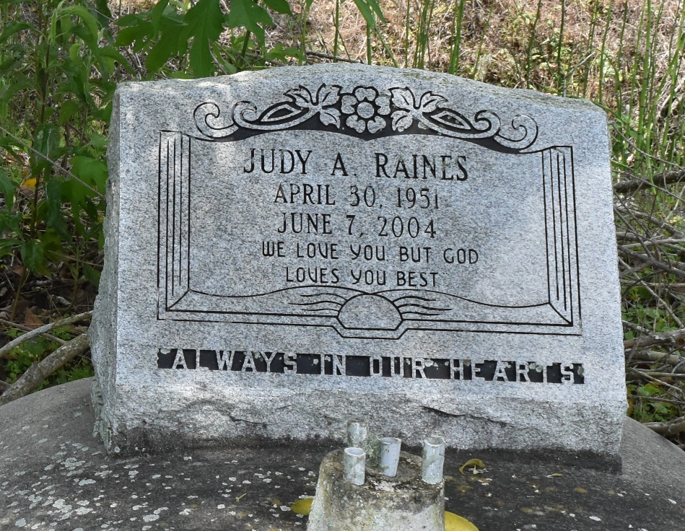

Judy Ann Matthews-Raines, age 53 years, passed away on Monday, June 7, 2004. Graveside Services will be held on Wednesday, June 16, 2004 at 11:00 a.m. at Second Baptist Church Cemetery, Highway 643, Vacherie, LA. Visitation on Tuesday, June 15, 2004 at Heritage Funeral Directors, Inc., 4101 St. Claude Avenue, New Orleans, LA from 1:00 p.m. until 5:00 p.m. Family, friends and members of Second Baptist Church, Vacherie, LA are invited to attend.
She leaves to cherish her many precious memories: her husband, Lawrence Raines; four daughters: Denise Baldwin, Michelle Dupre, Marsha Dupre and Stephanie Matthews; one stepdaughter, Sandra Raines; three sisters: Theresa Matthews-Plummer, Catherine Washington and Jackie Lovelace; 7 grandchildren, 1 great-grandchild; and a host of other relatives and friends. She was preceded in death by her parents: Landry Dumas and Pauline Dumas; and one brother, Eddie.
Arrangements are provided by: HERITAGE FUNERAL DIRECTORS - 944-5500

The Times-Picayune, New Orleans, Louisiana
Jun. 15, 2004

