Diane (Dumas) Simoneaux
November 2, 1947 – August 19, 2002

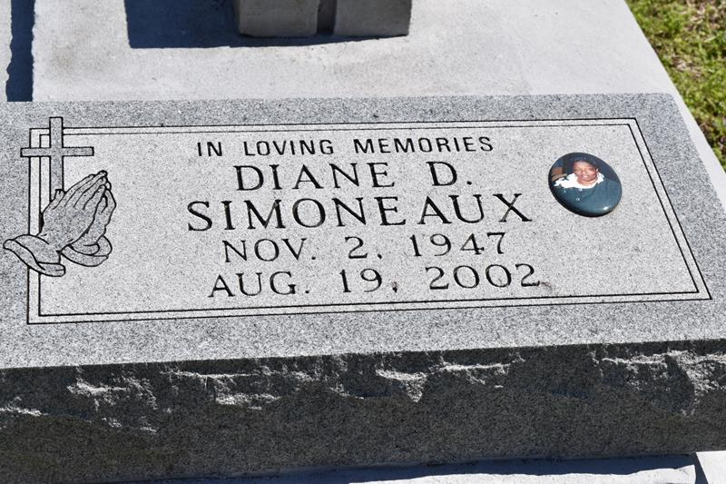

VACHERIE – Diane Dumas Simoneaux, 54, a native and resident of Vacherie, died Aug. 19. She was the mother of Ron Dumas. She was the daughter of the late Joshua Sr. and Mary Dumas and sister of Eliven Phillips, Julia and Mabel Bailey and Eugene, Simon, Joshua, Dennis, Joseph and the late Albert Dumas. She is also survived by two grandchildren.

Services are today at 11 a.m. at First Baptist Church, Vacherie, with interment at the church cemetery. Visitation starts at 8 a.m.

L’Observateur, LaPlace, Louisiana; Tuesday, August 27, 2002

