Na’Mari Collins
June 22, 2024 – June 22, 2024

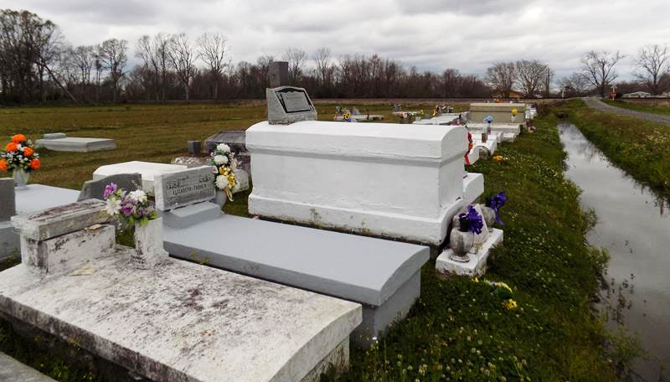

In the early morning of June 22, 2024, a new star graced our universe for a fleeting moment. Na'Mari Collins, born to Quai Collins and Naja Paul in Lutcher, Louisiana, was a brief yet radiant presence in our lives, leaving an indelible imprint on the hearts of those who loved her. Her life, though brief, was a testament to the profound impact a soul can have in such a short span. In her six hours of life, Na'Mari brought a lifetime of love, joy, and hope. Her spirit was a beacon, illuminating the lives of her heartsick parents. Her very existence, though ephemeral, was filled with profound meaning, reminding us all of the delicate balance of life and the preciousness of each moment. She was a testament to the sheer force of love, forever intertwining her parents' lives with her own brief existence. Na'Mari's short life was a lesson in giving and receiving love unconditionally.
Na'Mari Collins is survived by her loving parents, Quai Collins and Naja Paul. Her memory will forever be a source of strength and inspiration for them. They find solace in knowing that their love for her transcends the physical realm and is eternal.
We invite all who knew of Na'Mari and her family to share their memories and upload photos to the memorial page. Please join us in celebrating the brief, but impactful life of Na'Mari Collins, whose spirit will forever shine brightly in our hearts. A graveside burial was held on Wednesday, July 3rd, 2024 at Highway Baptist Church Cemetery conducted by Dr. Charles Oatis.

Treasures of Life Funeral Services, Gramercy, Louisiana

