Clarence Davontine
September 24, 1954 - January 6, 2025

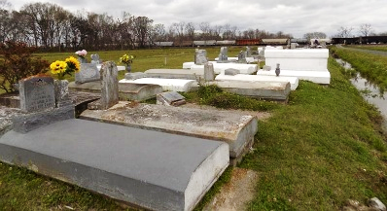

Our beloved Clarence, affectionately known as “Gummy,” quietly slipped away from us and departed his earthly home on Monday, January 6, 2025 at the age of 70. The love of Jesus gently delivered him from all sickness and took him home, where there shall be no more pain and suffering. Clarence was born on September 24, 1954 in New Orleans, Louisiana, to the late Joseph Deverteuil and the late Rosalee Joseph Nash. Clarence was married to Natalie Benoit Davontine and from this union was born one daughter, Chanedra Leguam Davontine.
Clarence attended Magnolia High School and enlisted in the United States Army in 1973. He attended bootcamp training in Fort Polk, Louisiana. His tenure in the Army allowed him to travel widely and embrace new experiences. He resided at Fort Sill in Lawton, Oklahoma for numerous years and later spent a tour in Germany. After completing his tour in the Army, he settled down in his hometown of Vacherie, Louisiana with his family.
Clarence can be characterized as a compassionate, caring and giving soul who would help anyone in need. He was affectionately known by nick names such as “Gummy” and “Breeze.” He was passionate about his family and his cars, often challenging his family to who had the nicest and cleanest car, and often commenting on how dirty his daughter Chinney and his niece Dee cars were. He never met a stranger and would give his last to his fellowman.
Clarence’s memories will be kept in the heart of his wife, Natalie B. Davontine, his daughter, Chanedra L. Davontine, his grandson, Kadon M. Davontine; sisters, Rose M. Ward (the late Joseph Ward) and Michele Horne (Reuben) of New Orleans, LA, and Laverne N. Armant (Carlos L. Julien) of Vacherie, LA; brothers, Lawrence Nash (the late Carternell V. Nash), Donald D. Nash (Betty), and Ronald P. Nash (Alicia) of Vacherie, LA, Joseph Deverteuil, Jr (Demetrill) and Rickey Deverteuil (Gwendolyn) of Gonzales, LA; devoted friend, Nick Oubre; and a host of nieces, nephews, relatives and friends.
Clarence is preceded in death by his father, Joseph Deverteuil; his mother, Rosalee Joseph Nash; his grandparents, Vanderbilt Joseph and Elnora Joseph; brother, Calvin Davontine; and sister, Lori Ann Nash.
A celebration of life, love, and legacy will be held on Wednesday, January 15, 2025 at First Baptist Church, 1244 Magnolia Heights Street, Vacherie, LA 70090. Visitation begins for 9am followed by service for 11am. Interment Highway Baptist Church Cemetery, Church Lane, Vacherie, LA 70090. Final care entrusted to

Treasures of Life Funeral Services, Gramercy, Louisiana
January 19, 2025

