Odeal (Stewart) Narcisse
November 3, 1926 - October 3, 2024

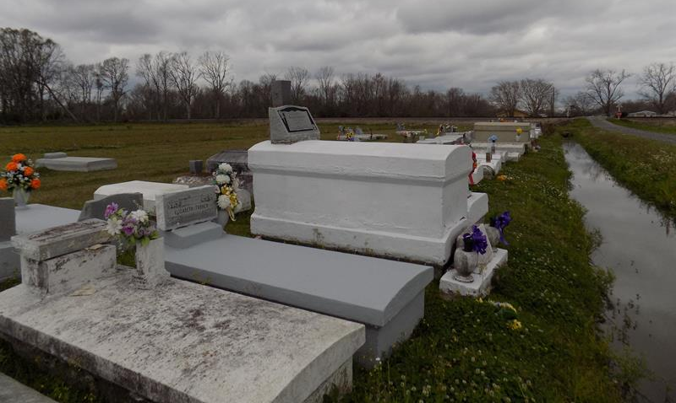

On Thursday, October 3, 2024 at approximately 6:45 p.m. our Lord and personal Savior dispatched his angels to carry Mrs. Odeal S. Narcisse to her heavenly home where she was reunited with her loving parents, the late Pleasant Sr. and Louisa Stewart, along with the love of her life, Rudolph “Robert” Narcisse Jr. as she referred to him as, “My Man.” She also joined their three children, granddaughters, and siblings. She was one of fifteen children.
Together Odeal and Rudolph Narcisse had thirteen children who they nurtured and trained in the Lord. She was baptized at a very early age by Rev. Emery. As a lifetime member of the Highway Baptist Church, she was also pastored by Rev. James Trench Sr, Rev. Ernest Howard Jr., Rev. Wesley Brown, and by Dr. Charles Oatis Sr. Her favorite book of the bible was Psalm 23 that she still could recite word for word about two months ago. Her favorite song was walk in the light. She was a dedicated member of the Highway Baptist Church and faithfully attended services until this year, at the age of ninety-seven years old. During her later days of sickness, she pressed her way to church where she enjoyed basking in the presence of the Lord, for she knew the time of her departure was at hand. When she began to get weak in her body, her family members prayed for a miracle for her, but God honored her request, “Father, I am now ready to come home with you.” The prepared Woman of God gladly received her wings, to fly away to meet her maker.
As she strongly fought her sickness, she humbly called on Jesus continuously in prayer, as she waited for that day to see her master’s face. She prepared her children by calling for all her children and grandchildren to say good-bye to them all in her own special way. As she was having conversations with them, she laid down her rules. She told them I love you all so much. I want you’all to live right, and do things the right way, and you’ll will be alright.
This Woman of God committed to her family and always willing to help others. She was not ashamed of the gospel of Christ. She enjoyed the all the messages that went forth in the church services. She was known for being in church all her life, under so many leaders, praising, standing up clapping her hands, swinging her arms and speaking out, “God have done so much for me, and I thank Him.” She loved to praise and worship God, so it was a great joy for her to walk in church, as well as being pushed in her wheeled chair at such an old age. Her favorite song was, “Jesus the Light of the World.” As she slept away peacefully, her final prayer was answered on October 3, she breathed her last breath surrounded by her children.
Her greatest joy was joining with her family members and having fun time by joking around. As much as she loved to joke around, she was also very spicy and sassy. If she said something and someone felt her words were offensive, she would immediately say, “I was just playing.” Everyone in her house, grandchildren, family members and friends knew her as the “Fried Bread Queen.” Our family members do believe that no-one did it like her. She lived by the motto; “If I can help somebody as I pass along my living will not be in vain.”
Her grandson Ronnie Narcisse stayed with her for years, just like her own child. After working at the Sugar Mill in the laboratory in her younger days, she stayed home and took care of her children, became the babysitter for so many of her grandchildren, and for many of her nieces and nephews’ children. She had rules to follow, but Trionne Washington bonded with her so quickly, she was known as Grandmoe to Trionne, and Odeal gained a Tudie. This is one way she showed love to her family members, and at the same time keeping her own grandchildren under control, as she loved on them.
Mrs. Odeal leaves to cherish her memories, her loving and caring family. Her ten children are: Gloria (Cleveland) Keller, of Vacherie, LA., Larry (Linda), Calvin (Denise) – and Hilton (Sue Won) Narcisse from St. James, LA., Brenda (Rev. Tyrone) Howard Sr., Debra Dumas, Bernadette and Harriet Narcisse – Vacherie, LA., Vincent Narcisse (Dallas, TX.), and Juanita Clarke of Gonzales, LA. She leaves thirty grandchildren, forty-six great-grandchildren, and seven great-great grandchildren. She also leaves her youngest brother, Pleasant Jr. (Mary) Stewart.
Mrs. Odeal’s beloved family members who proceeded her in death are her parents; Pleasant Sr. and Louisa Stewart, her husband, Rudolph Narcisse Sr., her children Jeanette Narcisse (died as an infant), Rudolph “Scoby” (Gloria) Narcisse III, and Jeanette N. and Sidney Warren, Son-in-Law (Melvin Dumas) granddaughters Seaneea Narcisse and LaTrese Cobbs. Sisters; Elizabeth (Rev. James Trench Sr.), Olivia (Morris) Lee, Helen (Willie) Davis, Rosalee (Emanuel) Hickerson Sr., Mildred (Justillien) Narcisse Sr., Barbara (Frank) Johnson, Essie (Danny) Lemieux. Brothers; Wallace, Newman, Wilbert, Vince, Brown, Felton Stewart, and Webster (Bessie) Stewart. A host of nieces and nephews, friends and loved ones.
A celebration service honoring her life and legacy will be held on Saturday, October 12, 2024 at Highway Baptist Church, 1185 Magnolia Heights Street, Vacherie, LA 70090. Visitation begins for 9am followed by service for 11am. Internment to follow at Highway Baptist Church Cemetery, 2532 Church St., Vacherie, LA 70090.

Treasures of Life Funeral Services, Gramercy, Louisiana
October 10, 2024

