Doris (Alexander) Pillette
August 9, 1954 – June 10, 2025

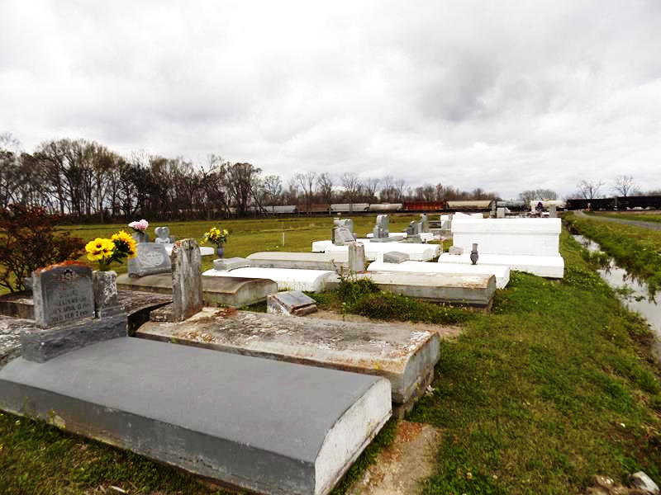

Doris Alexander Pillette, affectionally known as “Gram,” was born to the late Ophelia and James Alexander on August 9, 1954, in Donaldsonville, Louisiana. She was reared by the late Freida Landix.
She was a native of Donaldsonville, LA and a lifelong resident of Vacherie, LA. She graduated from Donaldsonville High School in 1972. Doris was employed by E.I. Dupont as an operator until her retirement in 1997. She met many co-workers that turned into lifelong family and friends; Leah Dunn, Terry Knight, Betty Octave, Dwight Alexis, Kimble Octave, and Clarence Tassin.
Doris professed her faith at an early age, and was baptized under the leadership of Pastor Percy Truehill at Emmanuel Baptist Church in Donaldsonville, LA. She was a dedicated member of Highway Baptist Church, where she served on the trustee board, a member of the choir, assistant secretary, and other auxiliaries until her health began to decline.
God blessed Doris and the late Norris Pillette, Jr with five beautiful children: Nikita, Kenya, Shawna, Jared, and Kayla. She was very dedicated to her family and raised her children in a home filled with love. She was full of life, laughter, and never met a stranger. She enjoyed reading, crafting, cooking, and she was a wordsmith.
She leaves to cherish her precious memories, Kenya Pillette Jack of Hahnville LA, Shawna (Jarvis) Pillette-Moll of Gonzales, LA, Jared Pillette of St. Gabriel, LA and Kayla Pillette of Vacherie, LA. She has 13 Grandchildren: D’Ara (DeQuincy) Pillette Roussell, Aspen K. Jack, Ashlyn Jack, Amari Jack, Madison Moll, Jayon Joshua, Mi’Asia Pillette, A’Niya Pillette, Dylan Pillette, Laila Pillette, Treazure Pillette, Tatum Joseph, and Zaire A. Johnson; Five great- grandchildren: Aiden Rafiel, Emori Narcisse, Alani Narcisse, Tre’mere Valentine, and Niri Russell; one uncle: William Baker, Sr.; siblings: Lois Williams, Mary(Clarence) Davis, Mildred Veal, Hilda Alexander, Ethel Wilson, Dawn Landix, Dianne (Harold) Taylor, Harriet (Donald) Brooks, James (Jerry Ann) Alexander, Sr., Murray (Sheila) Landix and Wayne (Jeanie) Landix; Sister-in-law Carolyn Alexander; Godchildren: Karen Alexander, Trieonne Washington and Rilynn Bazile; devoted caretakers Katrina Whittington and Debra Braxton; special friends: Cheryl Cayette, Margaret Washington, Equilla Bazile, Jovan Williams, along with a host of relatives and friends.
She was preceded in death by her parents James and Ophelia Alexander; a daughter: Nikita Pillette; granddaughter: Mi’Angel Pillette; great-grand daughter Nuri Russell; siblings: Ernest Bradley, Joseph Alexander, Sr., Lucille Bell, Ethel (Herbert) Cox, Donald Landix, and Vernell Landix; aunt Freida Landix.
A Celebration of Life will be held on Saturday, June 21, 2025 at Highway Baptist Church, 1185 Magnolia Heights, Vacherie, LA 70090; visitation from 8am to 10am with the service following for 10am.; Dr. Charles Oatis, Sr., Officiant. Interment Highway Baptist Church Cemetery, 2001 Church Ln, Vacherie, LA 70090.

Treasures of Life Funeral Services, Gramercy, Louisiana
June 18, 2025

