Norris Pillette, Jr.
November 24, 1952 – December 25, 2017

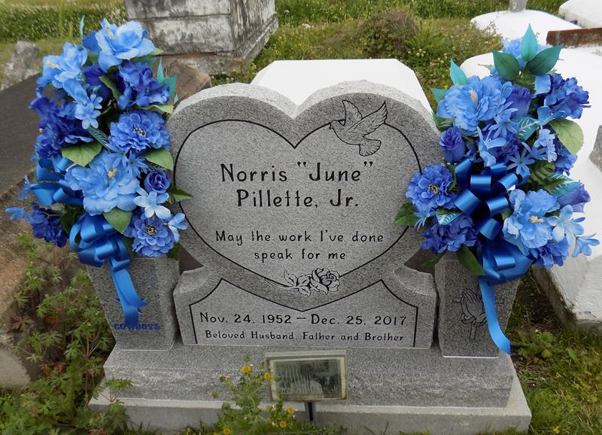

Norris Pillette Jr., 65, died peacefully on December 25, 2017 at his residence in Baton Rouge, LA. A native of Vacherie, LA.
He leaves to cherish his memories, wife Iris Cost-Pillette, six daughters: Kenya Jack, Shawna (Jarvis) Moll, Kayla Pillette, Brea (Kenneth) Breaux, Andrea Davis, and Lisha Bazile; three sons: Corey Polk, Jared Pillette, and Vacarri Bazile; four sisters: Yvonne (Ray) Breaux, Gwendolyn (Kenneth) Harrison, Fannie (Leroy) Nicholas, and Mary Louise Goodie; one brother Kibbie Pillette; 23 grandchildren including two special grandchildren: D'Ara Pillette and Aspen Jack; one great-grandchild, one aunt; Cleona Pillette and a host of other relatives and friends.
He was preceded in death by his parents, Mary Alice and Norris Pillette Sr. along with, two daughters; Deidra"Sheree"Cooke and Nikita Pillette and one brother, Oris Pillette.
There will be a gathering of family and friends on Friday December 29, 2017 from 5-7PM at Highway Baptist Church, 1185 Magnolia Heights St., Vacherie, LA 70090. Celebration of Life will be on Saturday, December 30, 2017 from Highway Baptist Church in Vacherie, LA at 1:00PM. Visitation from 11:00AM until service time. Rev. Wesley Brown, Officiating Pastor. Interment Highway Baptist Church Cemetery.

Treasures of Life Funeral Services, Gramercy, LA
June 18, 2025

