Ozane Edward Abadie Jr.
March 7, 1942 – July 30, 2017

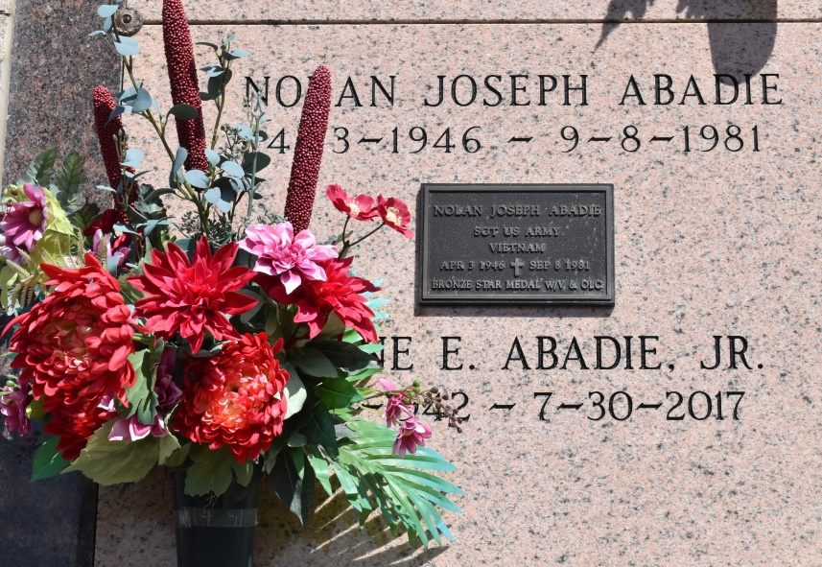
Ozane E. Abadie, Jr. (Junior), age 75, a native of Vacherie, LA passed away on Sunday, July 30, 2017 in Thibodaux, LA at Lafourche Nursing Home. A visitation will be held in his honor on Tuesday, August 1, 2017 at Our Lady of Peace Catholic Church, Vacherie, LA from 8:00 am to 11:00 am with a Mass of Christian Burial at 11:00 am. The burial will follow in the church mausoleum. Survived by his sisters; Madeleine (Norman) Lasserre, Rose Anne Mire, Clothilde (Gerard) Hymel, Judith (Huey) Kliebert, Vickie Schexnayder, Nancy (Clinton) Benoit, Jeanne (Tony) Clemente, Antoinette Abadie and brother, Kenneth (Sue) Abadie. Preceded in death by his parents, Ozane Sr. and Rose Gravois Abadie; sister, Marguerite Labat; brothers, Harold and Nolan; sisters-in-law, Louis and Brenda Abadie; brother-in-law, Dudley Labat, Robert Schexnayder and Richard Mire. Junior shadowed his brother Ted in the family's service station in Vacherie until closure. In lieu of flowers, masses preferred.
Advocate, The (Baton Rouge, LA) - Monday, July 31, 2017
Contributed by Jane Edson

