Brandon Whitney Adams
November 2, 1986 – January 20, 2007

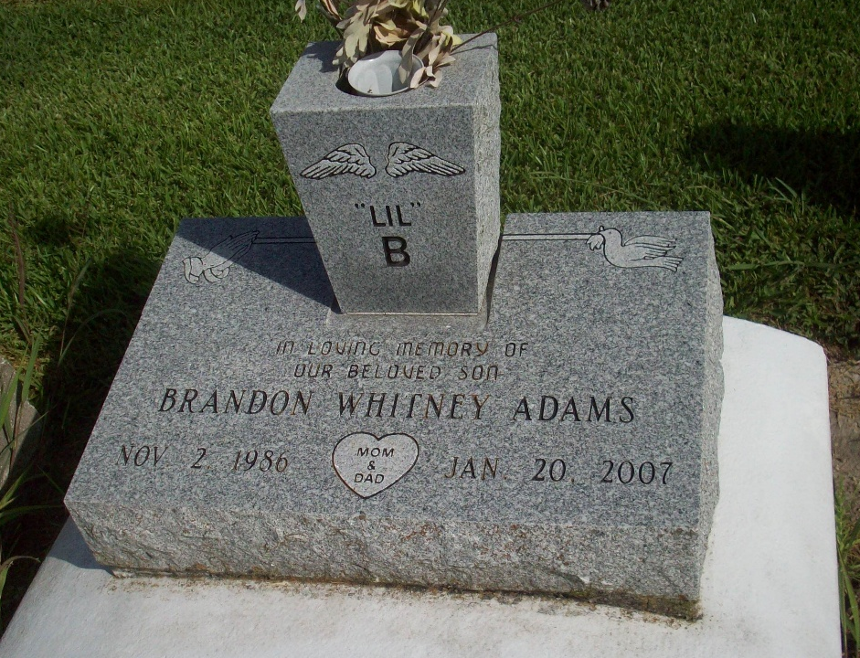
Photo by TMB

Brandon Whitney (Lil ""B'') Adams, on Sunday, January 21, 2007 at 12:10am, God summoned his warrior home. His life came to a peaceful end at Thibodaux Regional Hospital. A 2006 graduate of John Adams High School.
Son of Herman ""Ben'' Adams and Crystal Laurent. Stepson of Calvin Solomon. Brother of Barbara Adams, Dammon Lockett, Roy Hickman, Lance Lockett, Calvin Solomon II all of New Orleans, La. and Desmond Lockett of Quantico, Va. Grandson of Joseph Laurent, of Marrero, La., Gladys Adams of Laplace, La., Raymond Taylor, and Willie Solomon of New Orleans, La. Uncle of Tyree Adams. Godson of Lawrence Lear and Yolanda Rodgers. Companion of Shennika Albert. Also survived by a host of aunts, uncles, godsisters, cousins and friends. Preceded in death by his grandmother, Dorothy Irma Laurent. A native of New Orleans, La. and a resident of Lutcher, La. Age 20 years.
Relatives and friends of the family, also priest and parishioners of St. Phillip Catholic Church, are invited to attend a Mass of Christian Burial on Monday, January 29, 2007 at 11:00am from the St. Phillip Catholic Church, Hwy. 18, Vacherie, La. Father Louis Oubre, celebrant. Visitation at the church after 9:00am on Monday. Interment Our Lady of Peace Catholic Church Cemetery, Vacherie, La. THE BALONEY FUNERAL HOME LLC, 399 Earl Baloney Dr., Garyville, La. 70051 Information: (98) 535-2540 In charge of arrangements

The Times-Picayune, New Orleans, Louisiana
Jan. 28, 20073

