Joseph Bobby Adams
1933 – November 24, 2014

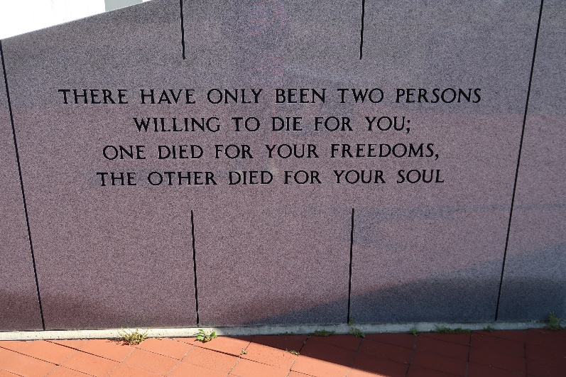

Joseph Bobby Adams, 81years of age, passed away on Monday, November 24, 2014. A Mass of Christian Burial will be held on Monday, December 1, 2014 at 11:00 am at St. Philip Catholic Church, 1175 Louisiana 18, Vacherie, LA 70090. Visitation will be held from 9:00 am, Rosary will begin at 9:30 until the hour of service. Interment, Our Lady of Peace Catholic Cemetery.
He leaves to cherish his many precious memories, his children, Deirdra A. (Vincent Sr.) Batiste, Donovan (Angela) Zenon, Shemika Murry, Ryshelle (Gary) Mizell, Elasha Washington; siblings, Hattie Honore,' Cecile (Joyce) Adams, Roy, Jeff, Peter, Ulysesses (Charles) Adams; grandchildren, Dior A. Batiste, Vincent Batiste Jr., Kierra Moody, Zharia Lemar, ZCoi Lemar, Mason Mizell, and Angelle Zenon and a host of nieces, nephews, and other relatives and friends.
Relatives, friends of the family, pastors, officers, and members of St. Mark Ministries of Mount Airy, LA, First Baptist Church of Vacherie, and neighboring churches are invited to attend.
He was preceded in death by his parents Lionel and Marie Favorite Adams and sister, Alice Joseph.
Special Thanks to Thibodaux General Hospital; Dr. Talluri and staff at St. Joseph Medical Clinic; St. Joseph Hospice and staff and Dr. Gregory and his staff. Arrangements by Heritage Funeral Directors (504) 944- 5500.

The Times-Picayune, New Orleans, Louisiana
November 28-30, 2014

