Donna Marie (Gauthe) Amedee
November 30, 1958 – October 23, 2016

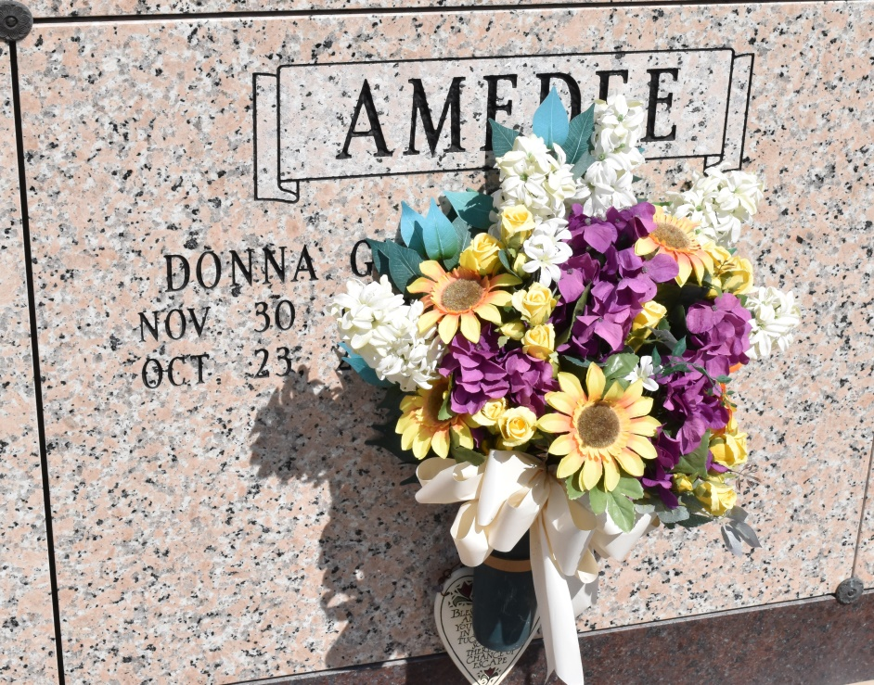
Donna Marie Gauthe' Amedee, 57, a native of Chackbay and a resident of Vacherie, passed away on October 23, 2016.
Visitation will be held from 8 AM until Memorial Service at 11 AM on Thursday, October 27, 2016 at Our lady of Peace Catholic Church of Vacherie, followed by the burial in Our Lady of Peace Cemetery.
She is survived by her husband, Roland Amedee Jr.; children, Mindy Lee Forrestier and husband, Clayton, Mitchell Louis Amedee and wife, Shellie, and Marcy Lynn Amedee; grandchildren, Grace Forrestier, Simone Forrestier, and Gavin Forrestier; brothers, Hubert "Pete" Gauthe' Jr. and Eric J. Gauthe'; and sisters, Marla G. Klibert and JoEllen G. Laurent.
She was preceded in death by her father, Hubert J. Gauthe' Sr.; and mother, Peggy L. Gauthe'; grandparents, Steven and Marie Gauthe', and Rena P. and Norbert Landry; and grandchild, Mylah Jolie Overfelt.
Samart Funeral Home is in charge of arrangements.
Houma Today, Terrebonne Parish, Louisiana
Oct. 25 to Oct. 26, 2016

