Nolan Joseph Amedee
April 17, 1935 – May 17, 2021

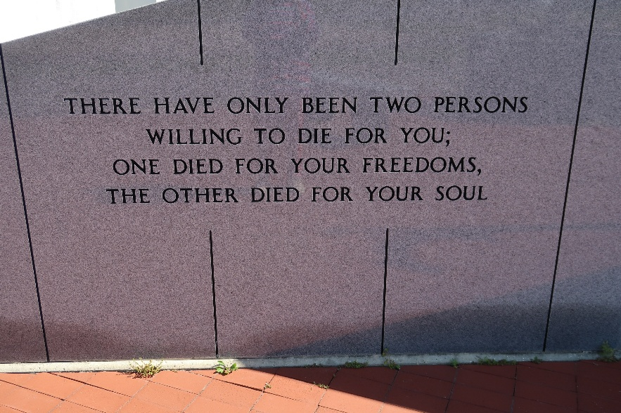

Nolan “White” Joseph Amedee, 86, a native and resident of Vacherie, Louisiana, died peacefully at his home surrounded by his family on Monday, May 17th 2021.
He was well known as the Lutcher/Vacherie Ferry Boat Captain, where he worked for 31 years. He was an avid gardener, tending to his seasonal vegetables and citrus trees. He was a witty, friendly gentleman with a great smile and personality. Growing up as one of eleven children on a farm called “Froggy Moe,” he was a hard worker, and taught his children and grandchild-ren the value of hard work and dedication.
As an active community member, he spent his time volunteering with the Woodmen of the World, Lions Club and Knights of Columbus Council #1514. He proudly served in The United States Army.
Visitation will be held at Our Lady of Peace Catholic Church in Vacherie, Louisiana on Wednesday, May 19th from 9:00 am until 11:00 am funeral time. Burial will take place in the Our Lady of Peace Cemetery following the Mass of Christian Burial.
He is survived by his loving wife of 59 years , Paulette Chauvin Amedee; daughter, Julie Amedee Waguespack and husband Seymour “Moe;” sons, Kevin Amedee and wife LaSherra, Todd Amedee and wife Connie, Brent Amedee and wife Nettie; grandchildren, Dwayne (Heather) and Leah Amedee, Tyler and Courtney Amedee, Corey (Natalie) and Callie Dauzat, Sydney, Phillip, Jude, and Aubrey Amedee, Jana Didia and Brett Waguespack; great grandchildren, Seaven, Reina, Kaisley, and Sage Amedee, Ava, Dauzat, Jayden and Abigail Didia; sisters, Mary Anne Folse, Jan Borne, Charlene Goan, Rosie Delatte; brothers, Gary, Lonnie and Wayne Amedee.
He was preceded in death by his parents, Ives Amedee and Cecile Becnel Amedee; brothers, Richard "Dick" and Frankie Amedee; sister, Hilda A Folse.
The family would like to say a special thanks to Haydel Memorial Hospice, Dr. Gregory Chaisson and everyone who cared for Nolan.

Thibodaux Funeral Home, Lafourche Parish, Louisiana

