Roland Joseph Amedee Sr.
November 16, 1929 – November 13, 2017

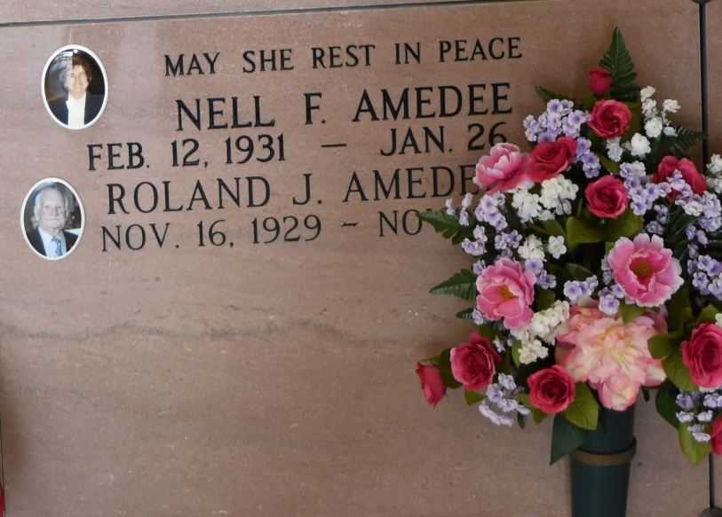
Roland Joseph Amedee Sr., 87, a native and resident of Vacherie, passed away on Nov. 13, 2017. A visitation will be held in his honor on Wednesday, Nov. 15, at Our Lady of Peace Catholic Church, Vacherie, from 8 a.m. until the Mass of Christian Burial at 11 a.m. The burial will follow in Our Lady of Peace Cemetery. He is survived by his children, Cherlyn Cazenave and husband, Michael, June Waguespack and husband, Carroll, and Roland J. Amedee Jr.; siblings, Amazelie "Mazelle" Rodrigue, Ralph Amedee, and Alvin Amedee; nine grandchildren; 18 great-grandchildren; and three great-great-grandchildren. He was preceded in death by his wife, Nell Falgoust Amedee; parents, Louis and Nazie Folse Amedee; brothers, Walter and Steven Amedee; daughter-in-law, Donna Gauthe Amedee; and great-granddaughter, Mylah Jolie Overfelt. He retired from Avondale Ship Yard in 1992 after many years of loyal work. He loved to spend time at his camp on Lac des Allemands crabbing and fishing but most of all; he enjoyed spending time with his family at his camp; where everyone was always welcomed. Landry's Funeral Home Inc. is in charge of arrangements.
Daily Comet (Thibodaux, LA) - Wednesday, November 15, 2017
Contributed by Jane Edson

