Cecile (Webre) Anderman
December 15, 1926 - February 12, 2024

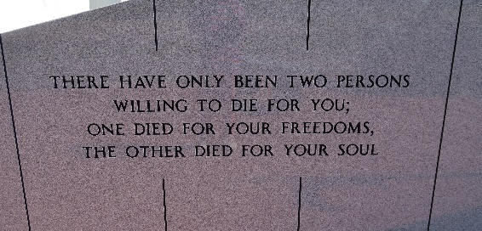

Cecile Miller Anderman, a native of St. James and a resident of Vacherie, LA, passed away Monday, February 12, 2024 at the age of 97.
She is survived by her children, Carolyn Veillon (John Sr.) and Juanita Roussel (Stephen); 5 grandchildren: John Veillon, Jr. (Dawn), Jeremy Veillon (Jamie), Justin Veillon (Jennifer), Scott Roussel, and Allison Roussel; 5 great grandchildren: Jeremiah, Jeanne, Jordyn, Ava, and Adalynn; and sister, Emeranthe Hymel.
She is preceded in death by her loving husbands, Nelson J. Miller and Raymon Anderman; parents, Murphy and Jeanne Webre; and sister, Adeline LaBruyere.
She cherished the time spent with her family. She had a passion for cooking, traveling, reading, sewing, arts & crafts, gardening, and most of all singing in the church choir. She was very proud of the many years of service working for the US Postal Service.
The family would like to thank the many caregivers over the past year for the exceptional care given to their mother.
Relatives and friends are invited to attend the Visitation and Funeral Mass at Our Lady of Peace Catholic Church, 13281 LA-644, Vacherie, LA on Thursday, February 15, 2024. Visitation will be held at church from 9:00 a.m. to 11:00 a.m. followed by a Funeral Mass at 11:00 a.m. Interment in Our Lady of Peace Church Cemetery, Vacherie, LA.
Rose Lynn Funeral Home, Lutcher, Louisiana

