George Myron Anderson
February 18, 1960 – July 26, 2018

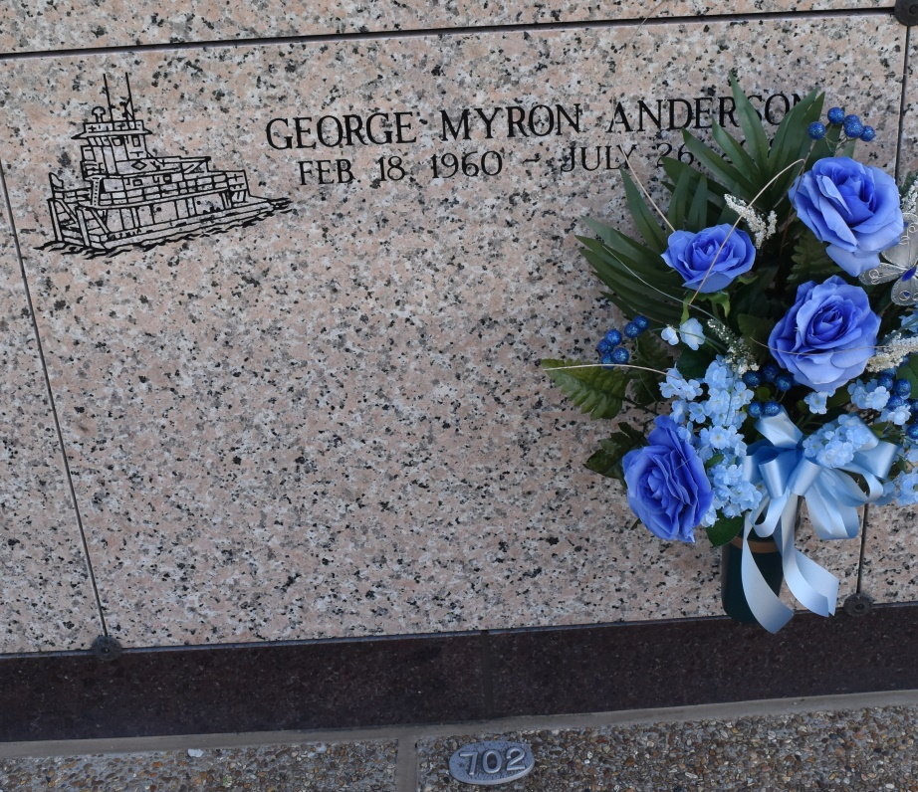
George Myron Anderson, 58, died July 26, 2018 at 4:22 PM. Born February 18, 1960, he was a native of Newton, MS and resident of Vacherie. He is survived by his wife of almost 30 years, Robin Reulet Anderson; son, Jacob Anderson; daughter, Mandi Owens; grandchildren, Mason and Thomas Stevens; brothers, Ronnie (Peggy) Anderson, Donnie (Alice) Anderson, Skeet (Hollis) Bailey, Johnny Bailey, Jack (Jeanie) McFee. He was preceded in death by his parents, Astor John Jacob and Ethel Marie Johnson Anderson; father and mother in law, Antoine and Frances Mahler Reulet; sister, Glenda Carlton; brothers, Joe and Jim McFee. He thoroughly enjoyed his job as a river boat captain and loved his family and dog Roscoe.
Daily Comet (Thibodaux, LA) - Saturday, July 28, 2018
Contributed by Jane Edson

