Timothy Paul Aucoin
March 10, 1965 – September 12, 2019

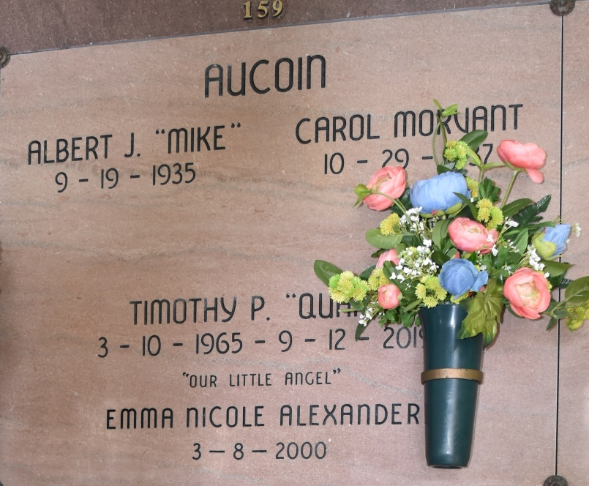
Timothy "Quank" Paul Aucoin, 54, native and resident of Vacherie, Louisiana passed away Thursday, September 12, 2019. He was a former cane farmer and previous employee of Oak Alley Plantation. Timothy truly enjoyed his work at the plantation and loved the people he worked with.
A memorial service will be held in his honor Wednesday, September 18, 2019 from 8:00 AM until the Mass of Christian Burial at 11:00 AM at Our Lady of Peace Catholic Church in Vacherie, Louisiana. Burial will take place in Our Lady Of Peace Catholic Church Cemetery following the Mass of Christian Burial.
He is survived by his parents, Albert "Mike" Aucoin and Carol Morvant Aucoin; his siblings; Anthony "Tony" Aucoin (Ellen), Bruce Aucoin (Janine), Edward "Eddie" Aucoin (Lisa), Wayne Aucoin (Neva), Dionne Aucoin Conrad (Donald Jr.); and numerous loving nieces and nephews.
He was preceded in death by his grandparents Edward and Lucia Durocher Aucoin, and Cameron Sr. and Glory Clause Morvant.
Landry's Funeral Home
Labadieville, Louisiana

