Beatrice (Steib) Baptiste
April 18, 1931 – July 7, 2001

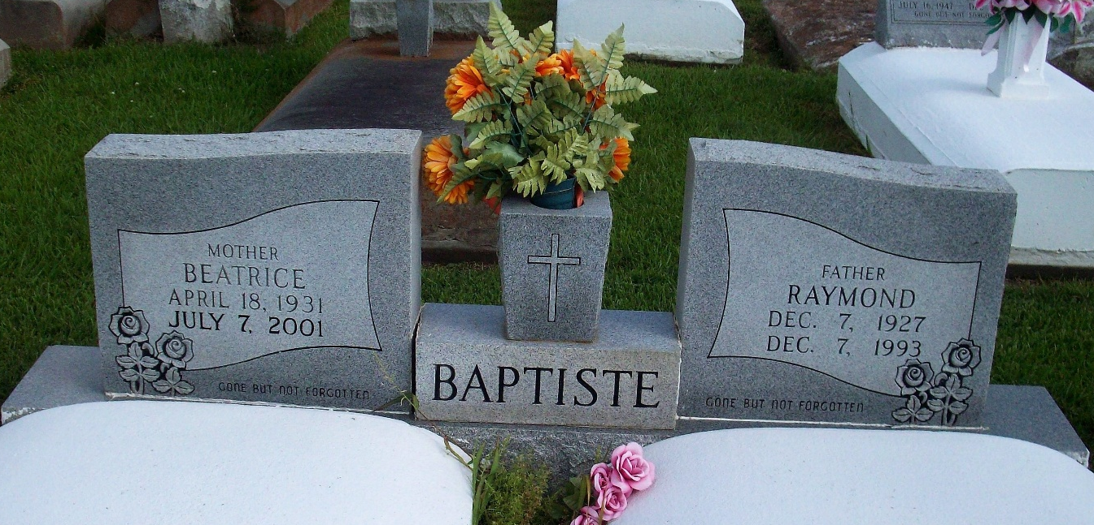
Photo by TMB

BAPTISTE SOUTH VACHERIE - Beatrice Steib Baptiste, 70, a native and resident of Vacherie, died July 7.

She was the wife of the late Raymond Baptiste and mother of Adam Paul Baptiste. She was also the daughter of the late Joseph E. and Josephia Philip Steib and sister of Olivia Joseph, Leona Dumas, Lydia Keller, Elroy Steib and the late Josephine Isom and Paul Steib. She is also survived by two grandchildren.

Services are today at 11 a.m. at Our Lady of Peace Catholic Church, South Vacherie, with interment at the church cemetery. Visitation starts at 8 a.m.
L'Observateur, LaPlace, Louisiana
Wednesday, July 11, 2001

