Derren Paul Baptiste
October 10, 1978 – March 9, 2026

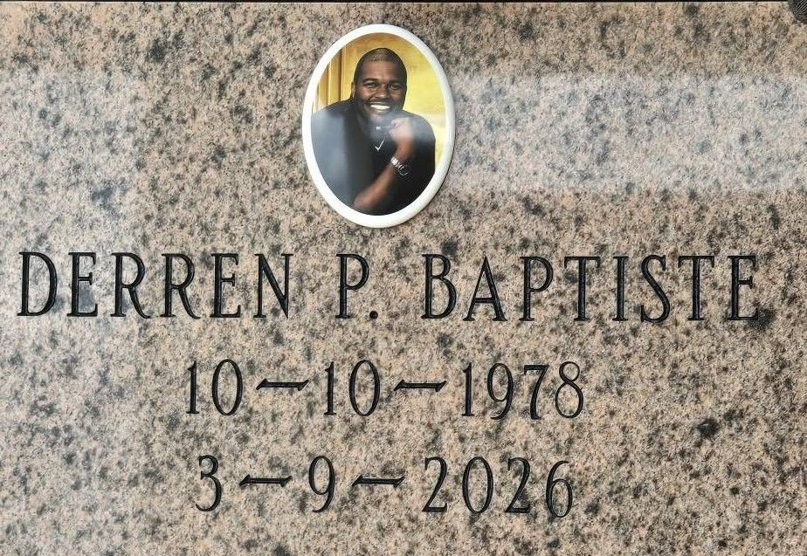
Photo by TMB

With profound sadness, the family of Derren Paul Baptiste announces his transition into eternal rest on Monday, March 9, 2026, at the age of 47. Born on October 10, 1978, Derren was the youngest child of the late Sidney J. Baptiste Sr. and Anita H. Batiste.
Derren was dedicated back to God at Our Lady of Peace Catholic Church in Vacherie, Louisiana, where he faithfully received and honored his sacred sacraments. His early years in Vacherie shaped the foundation of faith, family, and character that guided him throughout his life. A 1996 honor graduate of St. James High School, Derren earned a full four-year academic scholarship to McNeese State University in Lake Charles, Louisiana. He completed his studies with distinction, receiving a Bachelor of Science in Civil Engineering. After college, he pursued professional opportunities with determination, ultimately finding his path when he relocated to Houston, Texas, with his brother, Sidney Jr., and family. There, his career flourished, and his talents as a Professional Civil Engineer became widely recognized.
To all who knew him, it was clear: he built it all with skill, dedication, and pride. Derren was a lifelong member of Alpha Phi Alpha Fraternity, Incorporated. He became a member in Spring of 1999 at McNeese State University. He was a member of the Theta Theta Chapter.
On January 17, 2006, Derren united in marriage with Schrelle L. Baptiste, and together they shared 20 years of love, partnership, and devotion. Their greatest blessings came through their three daughters-Dyllen, Dailynn, and Dynver-who were the joy of his life and the heart of his legacy. Having lost his father at a young age, Derren was guided and strengthened by his uncle, August "Choke" Batiste, who became a second father to him. Through deep family bonds, Uncle Choke helped shape Derren into the strong, grounded, and honorable man he became.
Derren leaves to cherish his memory his devoted wife, Schrelle, and their beloved daughters, Dyllen, Dailynn, and Dynver. He is also survived by his loving mother, Anita H. Batiste; his sisters, Dr. Gail B. Brazile (Herbert) and Godmother Barbara Batiste; and his brother, Sidney Baptiste Jr. (Lana). He is fondly remembered by his nephew who was like a brother, James M. Gros Jr.; his godchildren, De'Andre Baptiste and Cherish Gibson-fros; his godfather, Rydell Melancon; his nieces and nephews; the extended LeBlanc family of Lake Charles; and a host of relatives and friends from near and far who will forever hold his memory close.
He is preceded in death by his father, Sidney J. Baptiste Sr.; his sister, Cindy B. Sutherland; and his brothers-in-law, Allan J. Sutherland and James Gros Sr.
Derren's life was a testament to resilience, faith, and unwavering love for his family. His legacy lives on in the structures he built, the lives he touched, and the family who will forever carry his memory in their hearts.
A Memorial Service in Derren's honor will be held at Our Lady of Peace Catholic Church, 13281 Hwy. 644, Vacherie, LA 70090 on Saturday, April 18, 2026; tribute for 10:15am followed by the Mass for 11:00am. A balloon release will be held immediately following Mass.

Treasures of Life Funeral Services, Gramercy, Louisiana

