Raymond Baptiste
December 7, 1927 – December 7, 1993

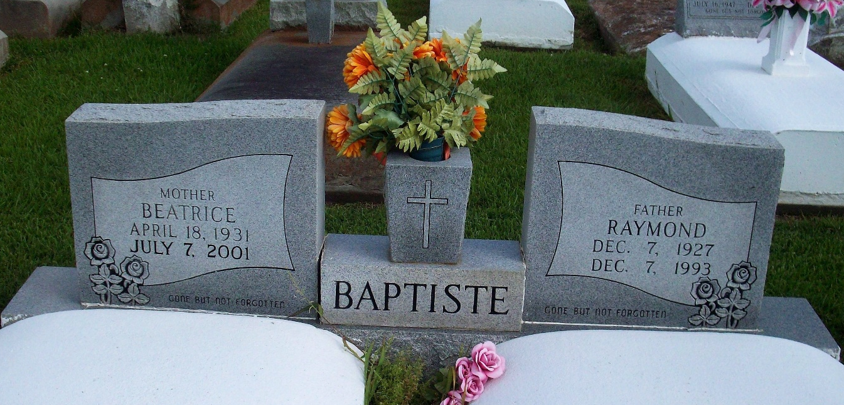
Photo by TMB

A Mass of Christian burial will be celebrated at 11 a.m. Saturday at Our Lady of Peace Catholic Church in Vacherie for Raymond "Boyo" Baptiste, 66, a native and resident of Vacherie, who died at 2:10 p.m. Tuesday, Dec. 7.1993
Visitation will be 8 a.m. to funeral time Saturday. Burial will be in the church cemetery.
He was the husband of Beatrice Steib Baptiste of Vacherie; father of Adam Baptiste of Vacherie; brother of Davis, August, Claude, Joseph and Wallace Baptiste, Mary Bovie and Octavia Harry, all of Vacherie, Mary Ann Jenkins of Chandler, Ind., and Sylvester Baptiste of LaPlace.
He was preceded in death by his parents, Antoine and Claudia L. Baptiste; and a brother, Sidney Baptiste Jr.
Southall Westside Funeral Home of Vacherie is in charge of arrangements.

Unknown source

