Edith (Saul) Barthelomew
February 10, 1915 – July 30, 2001

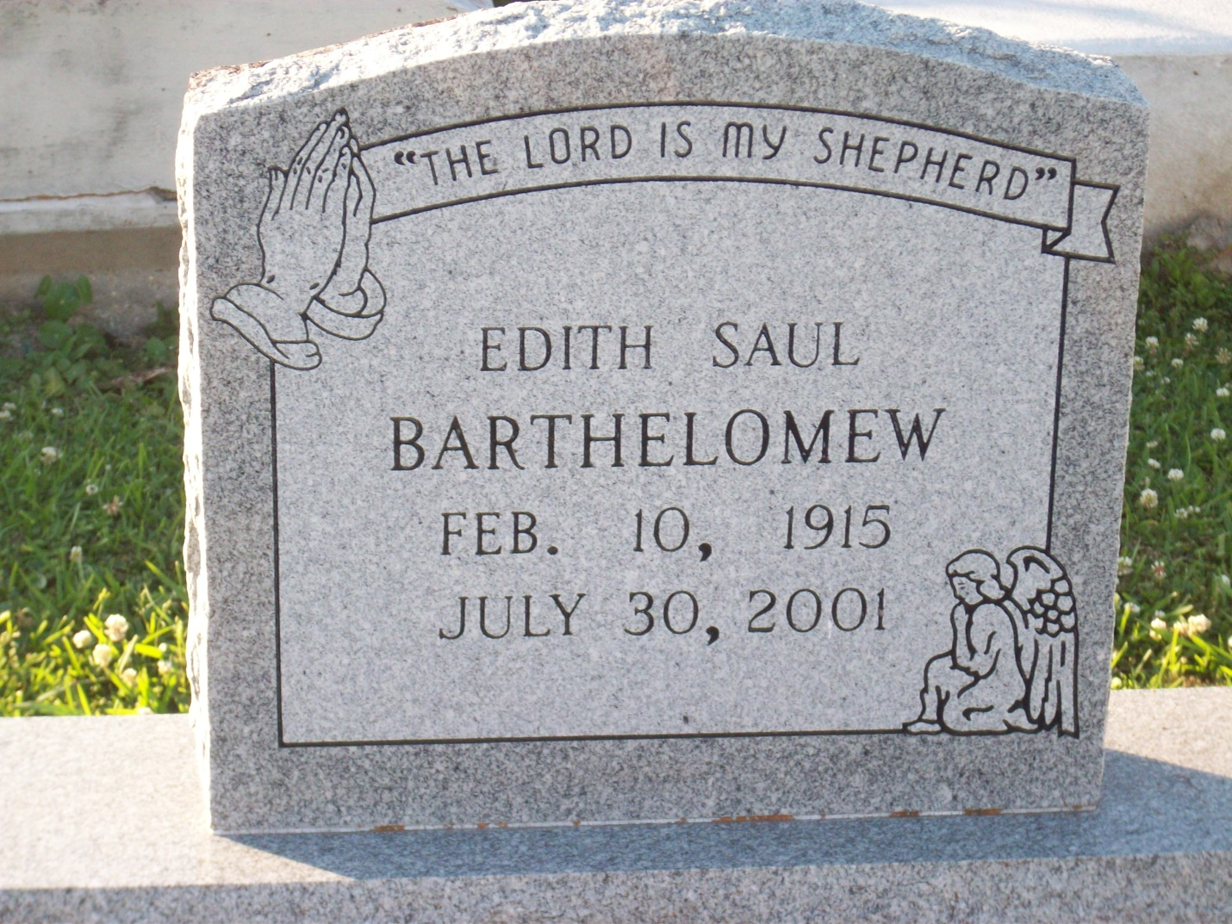
Photo by TMB

Edith Saul Barthelomew, a homemaker, died Monday of heart failure at West Jefferson Medical Center. She was 86. Mrs. Barthelomew was born in Vacherie and lived in Marrero for the past 65 years. She was a parishioner of St. Joseph the Worker Catholic Church. Survivors include her husband, John Barthelomew; three sons, Earlest, Arthur and Matthew Barthelomew; five daughters, Connie and Melba Barthelomew, Lois Dumas, Mary Love, and Judith Jackson; four brothers, Edmond, Joseph, Elmond and Edward Saul Jr.; 20 grandchildren; and 20 great-grandchildren.

Unknown source

