Brandon Nicholas Bartholomew
January 13, 1971 – August 22, 2002

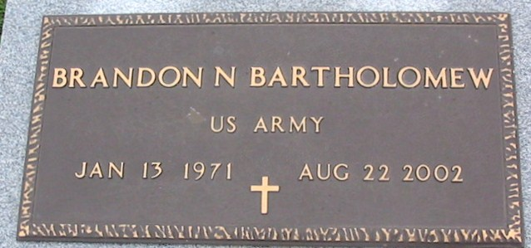
Photo by Bobby

BARTHOLOMEW, BRANDON NICHOLAS "NICK"
Died Thursday, Aug. 22, 2002, in Thibodaux. He was 31 and a native and resident of Vacherie. Visiting at Our Lady of Peace Catholic Church, south Vacherie, from 8 a.m. until religious service at 11 a.m. Thursday, conducted by the Rev. Henry Gautreau. Burial in church cemetery. Survived by his parents, Nelson and Cheryl Batiste Bartholomew of Vacherie; a brother, Keenan Desean Bartholomew; maternal grandmother, Equator Williams Batiste; paternal grandmother, Viola Lewis; and a host of aunts, uncles, nieces, nephews, other relatives and friends. Preceded in death by maternal grandfather, Albert Batiste; and paternal grandfather, Joseph Bartholomew. He was a U.S. Army veteran of the Persian Gulf War. Williams & Southall Funeral Home, Thibodaux, in charge of arrangements.

Advocate, The (Baton Rouge, LA) - Wednesday, August 28, 2002
Contributed by Jane Edson

